

Zbix CRM Quick Start Guide
  - Product release 1.2.0
Zbix Technologies
Documentation edition 1.2.0-r1
28 October 2026
A practical first-session guide from sign-in to prospect follow-up and qualification.
Use the contents to find a task, then review its prerequisites and expected result. Screenshots show demonstration data and preserve the original interface. Your permissions, organization layouts and enabled capabilities can change the controls you see.
Private review edition. Source-reviewed procedures have not been executed against a CRM installation as part of this documentation project. Platform acceptance and provider configuration require their stated qualification.
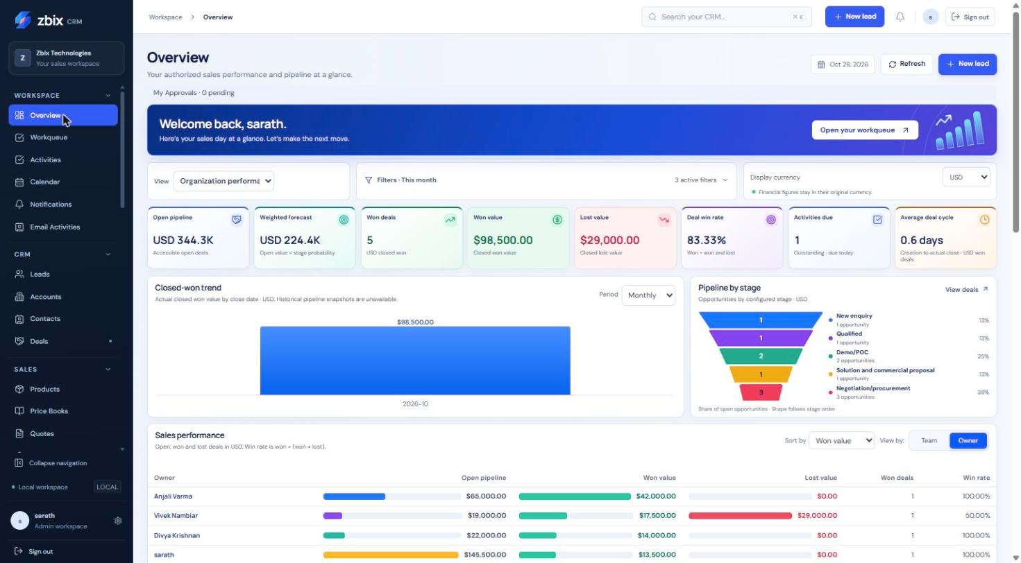
Zbix CRM Overview with demonstration sales information

Contents
Sign in and manage your session 3
Navigate lists and records 3
Your first day with Zbix CRM 4
Manage Leads 5
Convert a qualified Lead 6
Manage your daily Workqueue 7
Frequently asked questions 8

Sign in and manage your session
Zbix CRM 1.2.0 | Source reviewed | Reviewed 28 October 2026
Sign in uses your CRM email address and password. If authenticator protection is enabled, a second verification step follows the password check. A Microsoft 365 mailbox connection is separate from CRM sign-in.
Access the correct workspace and protect your session on shared devices.

Before you begin
- An active user account.
- A current password and, when enabled, your authenticator or unused recovery code.

Procedure
1. Open the CRM address supplied by your administrator and check that it is the expected site.
2. Enter your email address and password. Use the password visibility control only where nobody can observe the screen.
3. Choose Remember me only on a trusted personal device, then submit the sign-in form.
4. Complete the authenticator challenge when requested. If your organization requires enrollment, complete Security Settings before normal work.
5. At the end of work, select Sign out. If you changed your password, sign in again because existing sessions are revoked.

Expected result
The application opens your permitted workspace, or presents the next required authentication step.

Important considerations
- Idle and absolute session expiry still apply to persistent sessions.
- A password change requires 12 to 1024 characters in this release. Use a unique password.
- If password recovery is offered, use it only with your own account. Message submission does not prove that a recovery email reached your inbox.

Troubleshooting
- Invalid email or password: confirm the email, keyboard layout and active account status; do not repeatedly submit guesses.
- A session expires while editing: sign in, reopen the record and compare its current values before reapplying unsaved edits.
- Authenticator failure: use a fresh code and check device time; use an unused recovery code or the administrator recovery process if necessary.
Related knowledge base articles: Set up authenticator protection; Use the Settings hub and preferences; Your first day with Zbix CRM.

Navigate lists and records
Zbix CRM 1.2.0 | Source reviewed | Reviewed 28 October 2026
The left navigation groups workspace tasks, CRM records, sales, insights, automation and administration. List pages combine summary counts, search, filters, saved views and record tables. Detail pages provide the record information, related work and available actions.
Find the right record quickly and avoid confusing a filtered table with an organization-wide total.

Before you begin
- View permission for the required module.
- Access to the record through your effective own, team or organization visibility.

Procedure
1. Expand the relevant sidebar group and choose a module. Use the top search field to locate accessible records across supported modules.
2. Search within the list, choose a status or other available filters, and use the sort control. Clear filters if an expected record disappears.
3. Open Filters and views where available to define a bounded query, select columns or save a reusable view.
4. Open a record by its linked name. Use Edit, More or the dedicated action control for the operation you need.
5. Use Back to the module list, the sidebar, or the browser navigation controls to continue. Refresh after another user has changed a record.

Expected result
The list and record view show only information your current permissions allow.

Important considerations
- Many collection summary cards describe all accessible records while the table applies its own filters; read the note above the table.
- In this release Pipelines is in the Sales sidebar, while its breadcrumb reads Automation. Use the Pipelines item or Settings shortcut.
- A saved shared view stores a query; it does not grant access to another user's records or hidden fields.

Troubleshooting
- A list is empty: clear search/status/view filters and confirm visibility with an administrator.
- A stale-record conflict appears: refresh, compare changes and retry the intended update once.
- A relationship cannot be selected: confirm that the target record exists, is active where required and is within your access scope.
Related knowledge base articles: Create and update CRM records; Save filtered record views; Manage your daily Workqueue; Analyze performance with Reports.

Your first day with Zbix CRM
Zbix CRM 1.2.0 | Source reviewed | Reviewed 28 October 2026
A useful first session connects a prospect to a clear next action. Begin with your personal settings and daily queue, then create or update a Lead and record the follow-up. Convert only after qualification and relationship review.
Complete a small, end-to-end CRM workflow without prematurely issuing documents or activating automation.

Before you begin
- An active account with Lead and Activity permissions.
- A legitimate prospect record you are authorized to enter.

Procedure
1. Sign in and open Settings. Review your name, timezone and reminder preferences; complete required authenticator enrollment.
2. Open Workqueue and check Overdue and Today. Open each relevant activity before deciding what to complete or reschedule.
3. Open Leads, search for the prospect, and create a Lead only if a matching record does not exist. Enter Last name and Company, plus useful contact and qualification details.
4. Open the Lead and use Schedule an activity. Choose a task, call or meeting, give it a clear title and a due time, and save.
5. After qualification, update the Lead to Qualified. Review Account and Contact matches before using Convert lead. Choose whether the opportunity needs a Deal.
6. Return to Workqueue and verify the follow-up. Open Overview to see authorized sales information; do not expect every summary card to respond to list-table filters.

Expected result
The prospect has a usable CRM record and an assigned next action; any conversion preserves links to the resulting customer records.

Important considerations
- Use a training workspace for practice when one is provided. Demonstration screenshots do not authorize making test records in a live customer database.
- Mark an activity Completed only when the work has been done.
- Sending email is a separate, explicit action from saving a draft or marking a quotation Sent.

Troubleshooting
- The new activity is missing: check its owner, due date, completion state and Workqueue scope.
- Conversion is unavailable: the Lead must be Qualified and your role must permit the required operations.
Related knowledge base articles: Sign in and manage your session; Manage Leads; Record tasks calls and meetings; Manage your daily Workqueue; Convert a qualified Lead.

Manage Leads
Zbix CRM 1.2.0 | Source reviewed | Reviewed 28 October 2026
A Lead represents a prospect before conversion into an Account, Contact and optionally a Deal. Lead details also expose revenue planning, business-process controls, sales automation activity and assignment history when those capabilities are enabled.
Qualify prospects, capture contact context and keep a clear follow-up before conversion.

Before you begin
- Lead view/create/edit permissions as appropriate.
- Assign permission to change the owner.
- Any custom data required by the published Lead layout.

Procedure
1. Open CRM > Leads and search by name, company or email. Review the status and rating before creating a duplicate.
2. Select Create lead. Complete Last name and Company, then enter First name, Email, Phone and Job title where known.
3. Choose Status, Rating and Lead source. Add Industry, Estimated value, Country, Website and Description as useful to qualification.
4. Review the Record owner and custom fields, then select Save lead.
5. Open the Lead to add a note, schedule an activity and review any business-process instructions. Update the status as qualification progresses.
6. When the prospect is ready, set Qualified and follow the separate conversion procedure. Do not manually set Converted.

Expected result
A prospect is saved with an owner, qualification state and actionable history.

Fields and controls
Field or control | Rule
Last name and Company | Required in the standard create form.
Status | New, Contacted, Qualified or Unqualified before conversion.
Rating | Hot, Warm or Cold.
Estimated value | Nonnegative numeric prospect estimate.
Lead source | Website, Referral, Event, Partner, Outbound or Other.

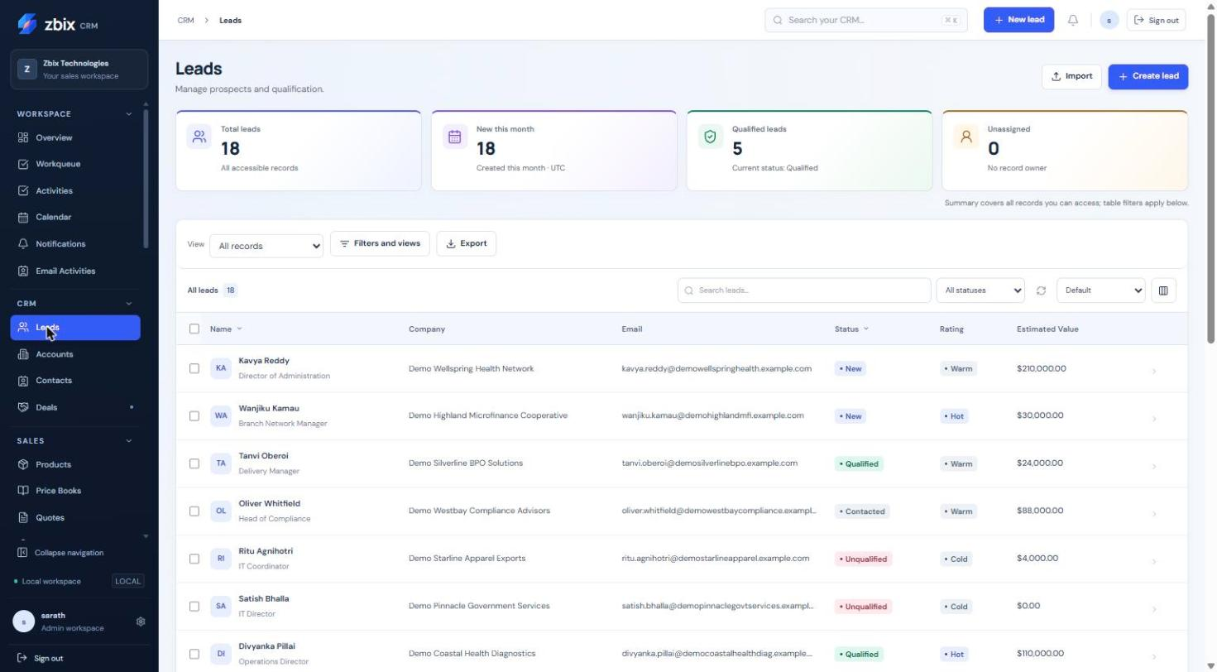
Figure 1 Leads list SS-007

Important considerations
- The standard status choices are New, Contacted, Qualified and Unqualified; conversion sets Converted through a controlled operation.
- An email cannot duplicate another active Lead email in the organization, even if that other Lead is outside your visibility.
- The screenshot contains custom fields added for the demonstration workspace. Your published layout may differ.

Troubleshooting
- Cannot save: complete starred/custom required fields and correct invalid email or amount.
- Duplicate email: ask the owner or administrator to locate the existing Lead.
- Cannot edit a converted Lead: work in the linked Account, Contact or Deal instead.
Related knowledge base articles: Convert a qualified Lead; Record tasks calls and meetings; Manage Accounts; Manage Deals and pipeline stages.

Convert a qualified Lead
Zbix CRM 1.2.0 | Source reviewed | Reviewed 28 October 2026
Lead conversion connects a qualified prospect to an Account and Contact and can create or link a Deal. Matching existing records avoids parallel customer histories. The operation preserves conversion references on the Lead.
Move a qualified prospect into the customer and opportunity records used for ongoing sales.

Before you begin
- Lead status Qualified and permission to edit it.
- Permission to create any new Account, Contact or Deal and read any existing targets.
- Consistent Account, Contact and Deal relationships.

Procedure
1. Open the qualified Lead and choose Convert lead from the available record action.
2. Search for an existing Account. Select it, or enter a distinct new Account name when no suitable record exists.
3. Choose an existing Contact belonging to that Account or create a new Contact from the prospect details.
4. Choose whether to create a Deal, link an existing open Deal, or convert without one. An existing Deal must have the same Account and primary Contact.
5. For a new Deal review its name, currency, amount, pipeline, stage and expected close date. If the Lead has a revenue plan, review its transferred planning values.
6. Confirm conversion, then open the resulting Account, Contact and optional Deal to verify the links.

Expected result
The Lead becomes Converted and retains links to the resulting records. Repeating a completed conversion returns its existing result rather than creating another set.

Important considerations
- Existing target records cannot be edited as part of conversion. Correct them separately before retrying.
- A closed Deal cannot be selected. Its Account, primary Contact and currency must be coherent.
- Conversion is blocked while a Lead is governed by a Blueprint. Ask an administrator to review the applicable process; do not try to bypass it through another screen.

Troubleshooting
- Only qualified leads may be converted: update qualification through the permitted process first.
- Matching Account already exists: choose that Account rather than changing capitalization to evade the match.
- Lead changed: refresh and review the newest version before submitting again.
Related knowledge base articles: Manage Leads; Manage Accounts; Manage Contacts; Manage Deals and pipeline stages; Blueprints.

Manage your daily Workqueue
Zbix CRM 1.2.0 | Source reviewed | Reviewed 28 October 2026
Workqueue brings tasks, calls, meetings and reminders into a due-date view. Open, Overdue, Today, Upcoming and Completed counters help you move from planning to action. Queue entries link back to their source record.
Review pending work, complete finished activities and move appointments deliberately.

Before you begin
- View access to Activities or the related scheduled work.
- Edit permission on an activity to complete or reschedule it.

Procedure
1. Open Workspace > Workqueue. Begin with Mine, or choose Team or All accessible when your role permits it.
2. Choose Overdue or Today, then narrow by work type or search text. Review the related record and the due date before acting.
3. Open the item to read its details. Use the completion control after the task is finished.
4. Use Reschedule to choose a new date and time when work must move. For meetings, check start, end and timezone together.
5. Use Schedule activity for new work. Select its type, record association, title, owner and timing, then save.
6. Refresh the queue and confirm the item moved to the appropriate due bucket or Completed.

Expected result
Activities retain their record association and reflect the updated completion or schedule state.
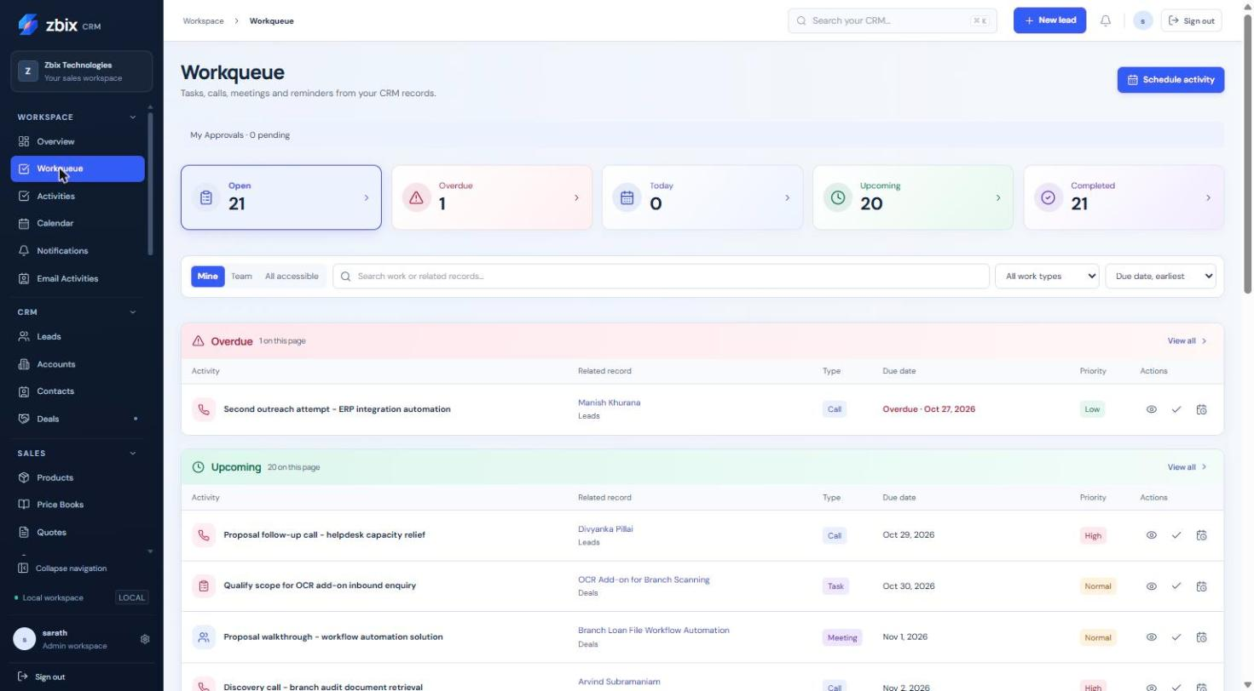
Figure 2 Task/call/meeting queue SS-002

Important considerations
- Completing a task is different from cancelling a scheduled job. Use the action shown for that source type.
- Meeting rescheduling moves its start/end and associated reminder together.
- Scope controls cannot reveal work outside the underlying record and module permissions.

Troubleshooting
- A work item has no action: your role may allow reading but not editing that source.
- An overdue item remains after work: verify the saved Activity status is Completed and refresh.
- A reminder is late: ask an administrator to check worker heartbeat and due-job age.
Related knowledge base articles: Record tasks calls and meetings; Plan meetings in Calendar; Review notifications and scheduled jobs; Read the Overview dashboard.

Frequently asked questions
Zbix CRM 1.2.0 | Source reviewed | Reviewed 28 October 2026
These answers address common differences between what users see in a list, what a document status means and which actions require administrative help.
Resolve frequent onboarding questions before changing data or requesting broader access.

Before you begin
- Access to your own workspace.

Procedure
1. If a colleague sees more records, compare effective role and own/team/organization visibility. Ask for the specific access needed for your work.
2. If a saved view or report is shared, remember that it shares a definition and still respects the viewer's record and field permissions.
3. If a Quote is Sent, verify whether an Email Activity was separately queued. The quote status alone does not send mail.
4. If an email is Accepted, inspect provider history when delivery is important. Accepted is submission acknowledgment, not inbox receipt.
5. If a payment is recorded, reconcile it with the actual transaction. CRM payment history does not charge the customer.
6. If a record or commercial document is locked, use its revision, transition or approval workflow rather than creating an unlinked duplicate.

Expected result
You can distinguish expected product controls from problems that need support.

Important considerations
- An empty screenshot or list does not mean a capability is missing.
- A role title is insufficient to infer permissions; inspect effective access.
- The documentation describes the release baseline, while your organization controls published layouts, stages and enabled capabilities.

Troubleshooting
- Still blocked: record the page, operation, time and exact safe error message. Include a redacted screenshot and ask your administrator to verify access and version.
- Do not attach passwords, authentication codes, tokens, private keys or unredacted configuration to a support request.
Related knowledge base articles: Navigate lists and records; Module Permissions; Create and send Email Activities; Issue Invoices and record payments; Collect useful support evidence.

