

Zbix CRM End User Manual
  - Product release 1.2.0
Zbix Technologies
Documentation edition 1.2.0-r1
28 October 2026
Daily use of Zbix CRM for sales teams, relationship owners and customer-facing staff.
Use the contents to find a task, then review its prerequisites and expected result. Screenshots show demonstration data and preserve the original interface. Your permissions, organization layouts and enabled capabilities can change the controls you see.
Private review edition. Source-reviewed procedures have not been executed against a CRM installation as part of this documentation project. Platform acceptance and provider configuration require their stated qualification.
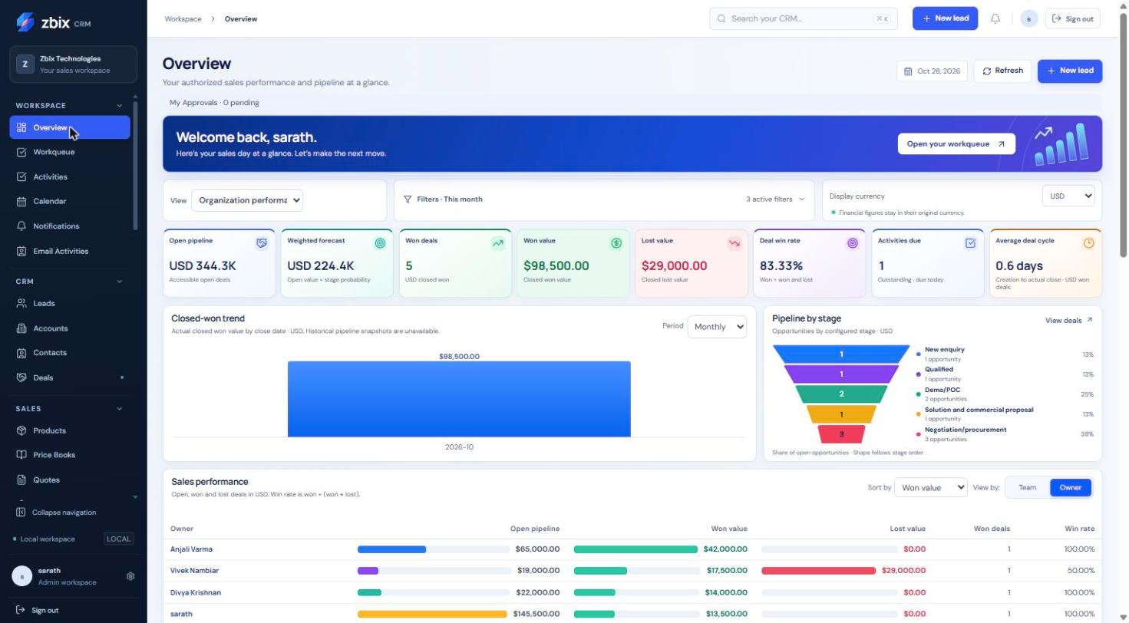
Zbix CRM Overview with demonstration sales information

Contents
Introduction to Zbix CRM 3
Sign in and manage your session 3
Navigate lists and records 4
Create and update CRM records 5
Your first day with Zbix CRM 6
Read the Overview dashboard 6
Manage your daily Workqueue 7
Record tasks calls and meetings 8
Plan meetings in Calendar 10
Review notifications and scheduled jobs 11
Create and send Email Activities 12
Reuse email templates 13
Manage Leads 14
Convert a qualified Lead 16
Manage Accounts 17
Manage Contacts 19
Manage Deals and pipeline stages 20
Maintain the Products catalog 21
Configure and use Price Books 22
Prepare and manage Quotes 23
Create and progress Sales Orders 25
Issue Invoices and record payments 26
Analyze performance with Reports 27
Create and share Saved Reports 28
Save filtered record views 29
Attach and retrieve record files 30
Frequently asked questions 31
Contracts 31
Recurring Billing 33
Billing Runs 35
Recurring Revenue 36
Revenue Settings 38

Introduction to Zbix CRM
Zbix CRM 1.2.0 | Source reviewed | Reviewed 28 October 2026
Zbix CRM brings prospect qualification, account relationships, sales opportunities, commercial documents and follow-up work into one workspace. Sales teams begin with Leads, organize customers in Accounts and Contacts, and track opportunities in Deals. Administrators configure access, sales processes, communications and operational services.
Use this guide to choose the next task and understand which parts of the application affect customer records, money, or background work.

Before you begin
- An account created by your CRM administrator.
- Your organization's CRM address and enabled product capabilities.

Procedure
1. Sign in at your organization's assigned CRM address. For the Zbix demonstration service, use the address supplied with your demonstration account.
2. Open Overview for a performance summary, then Workqueue to review immediate follow-up work.
3. Use CRM to find or create a Lead, Account, Contact or Deal. Search existing records before creating a second copy.
4. Use Sales for Products, Price Books, Quotes, Sales Orders, Invoices and recurring commercial agreements.
5. Use Insights to review authorized reports. Ask your administrator to configure Automation and Administration features when required.

Expected result
You can choose the appropriate module and understand the relationship between prospect records, follow-up work and commercial documents.

Important considerations
- This edition documents the v1.2.0 application release. Screenshots show demonstration data captured on 28 October 2026; their counts, currencies and names are examples, not defaults.
- Available navigation depends on current permissions, enabled capabilities and configuration. A missing module does not necessarily mean a fault.
- A cloud-hosted self-hosted installation and a managed SaaS service have different operational responsibilities. The SaaS readiness reference explains the distinction.

Troubleshooting
- A menu item is missing: ask the administrator to check the module role, feature availability and license capability.
- A screenshot looks different: compare the installed version and organization configuration before following a changed control.
Related knowledge base articles: Sign in and manage your session; Navigate lists and records; Your first day with Zbix CRM; Read the Overview dashboard.

Sign in and manage your session
Zbix CRM 1.2.0 | Source reviewed | Reviewed 28 October 2026
Sign in uses your CRM email address and password. If authenticator protection is enabled, a second verification step follows the password check. A Microsoft 365 mailbox connection is separate from CRM sign-in.
Access the correct workspace and protect your session on shared devices.

Before you begin
- An active user account.
- A current password and, when enabled, your authenticator or unused recovery code.

Procedure
1. Open the CRM address supplied by your administrator and check that it is the expected site.
2. Enter your email address and password. Use the password visibility control only where nobody can observe the screen.
3. Choose Remember me only on a trusted personal device, then submit the sign-in form.
4. Complete the authenticator challenge when requested. If your organization requires enrollment, complete Security Settings before normal work.
5. At the end of work, select Sign out. If you changed your password, sign in again because existing sessions are revoked.

Expected result
The application opens your permitted workspace, or presents the next required authentication step.

Important considerations
- Idle and absolute session expiry still apply to persistent sessions.
- A password change requires 12 to 1024 characters in this release. Use a unique password.
- If password recovery is offered, use it only with your own account. Message submission does not prove that a recovery email reached your inbox.

Troubleshooting
- Invalid email or password: confirm the email, keyboard layout and active account status; do not repeatedly submit guesses.
- A session expires while editing: sign in, reopen the record and compare its current values before reapplying unsaved edits.
- Authenticator failure: use a fresh code and check device time; use an unused recovery code or the administrator recovery process if necessary.
Related knowledge base articles: Set up authenticator protection; Use the Settings hub and preferences; Your first day with Zbix CRM.

Navigate lists and records
Zbix CRM 1.2.0 | Source reviewed | Reviewed 28 October 2026
The left navigation groups workspace tasks, CRM records, sales, insights, automation and administration. List pages combine summary counts, search, filters, saved views and record tables. Detail pages provide the record information, related work and available actions.
Find the right record quickly and avoid confusing a filtered table with an organization-wide total.

Before you begin
- View permission for the required module.
- Access to the record through your effective own, team or organization visibility.

Procedure
1. Expand the relevant sidebar group and choose a module. Use the top search field to locate accessible records across supported modules.
2. Search within the list, choose a status or other available filters, and use the sort control. Clear filters if an expected record disappears.
3. Open Filters and views where available to define a bounded query, select columns or save a reusable view.
4. Open a record by its linked name. Use Edit, More or the dedicated action control for the operation you need.
5. Use Back to the module list, the sidebar, or the browser navigation controls to continue. Refresh after another user has changed a record.

Expected result
The list and record view show only information your current permissions allow.

Important considerations
- Many collection summary cards describe all accessible records while the table applies its own filters; read the note above the table.
- In this release Pipelines is in the Sales sidebar, while its breadcrumb reads Automation. Use the Pipelines item or Settings shortcut.
- A saved shared view stores a query; it does not grant access to another user's records or hidden fields.

Troubleshooting
- A list is empty: clear search/status/view filters and confirm visibility with an administrator.
- A stale-record conflict appears: refresh, compare changes and retry the intended update once.
- A relationship cannot be selected: confirm that the target record exists, is active where required and is within your access scope.
Related knowledge base articles: Create and update CRM records; Save filtered record views; Manage your daily Workqueue; Analyze performance with Reports.

Create and update CRM records
Zbix CRM 1.2.0 | Source reviewed | Reviewed 28 October 2026
Leads, Accounts, Contacts, Deals, Activities, Products and Quotes use consistent list and detail patterns. Each module also applies its own relationships, validation and lifecycle rules. Published organization layouts may add required fields or rearrange the form.
Maintain reliable customer information while preserving ownership and history.

Before you begin
- Create or edit permission for the target module.
- Assign permission if you will select a different owner.
- The related Account, Contact or Deal, when needed.

Procedure
1. Search for an existing record before choosing Create. A matching email or product code may already exist outside your visible list.
2. Select Create on the module page and complete all starred fields. Use relationship lookups instead of copying names into unrelated fields.
3. Enter valid email addresses, nonnegative monetary values and the intended currency. Review custom fields and section headings configured by your administrator.
4. Save, then open the record to confirm its owner, relationships and values.
5. For later changes select Edit, save the revised values, and review available history or timeline information. Use dedicated lifecycle actions for conversion, approval or issuance.

Expected result
The validated record is saved and becomes available within its permitted scope.

Important considerations
- Record names are limited to 200 characters. Lead/contact email duplication is checked within the same module and organization; product codes are also checked.
- Converted Leads and finalized commercial snapshots have controlled editing restrictions.
- Delete and bulk actions can affect multiple records. Review the selected rows and the displayed confirmation before proceeding.

Troubleshooting
- Duplicate email or code: search and update the existing record or ask an authorized colleague to resolve it.
- The form rejects a relationship: a Contact must belong to the selected Account, and commercial relationships must match the selected Deal.
- Required custom data is missing: complete the configured field rather than replacing the layout.
Related knowledge base articles: Manage Leads; Manage Accounts; Manage Contacts; Manage Deals and pipeline stages; Fields and Layouts.

Your first day with Zbix CRM
Zbix CRM 1.2.0 | Source reviewed | Reviewed 28 October 2026
A useful first session connects a prospect to a clear next action. Begin with your personal settings and daily queue, then create or update a Lead and record the follow-up. Convert only after qualification and relationship review.
Complete a small, end-to-end CRM workflow without prematurely issuing documents or activating automation.

Before you begin
- An active account with Lead and Activity permissions.
- A legitimate prospect record you are authorized to enter.

Procedure
1. Sign in and open Settings. Review your name, timezone and reminder preferences; complete required authenticator enrollment.
2. Open Workqueue and check Overdue and Today. Open each relevant activity before deciding what to complete or reschedule.
3. Open Leads, search for the prospect, and create a Lead only if a matching record does not exist. Enter Last name and Company, plus useful contact and qualification details.
4. Open the Lead and use Schedule an activity. Choose a task, call or meeting, give it a clear title and a due time, and save.
5. After qualification, update the Lead to Qualified. Review Account and Contact matches before using Convert lead. Choose whether the opportunity needs a Deal.
6. Return to Workqueue and verify the follow-up. Open Overview to see authorized sales information; do not expect every summary card to respond to list-table filters.

Expected result
The prospect has a usable CRM record and an assigned next action; any conversion preserves links to the resulting customer records.

Important considerations
- Use a training workspace for practice when one is provided. Demonstration screenshots do not authorize making test records in a live customer database.
- Mark an activity Completed only when the work has been done.
- Sending email is a separate, explicit action from saving a draft or marking a quotation Sent.

Troubleshooting
- The new activity is missing: check its owner, due date, completion state and Workqueue scope.
- Conversion is unavailable: the Lead must be Qualified and your role must permit the required operations.
Related knowledge base articles: Sign in and manage your session; Manage Leads; Record tasks calls and meetings; Manage your daily Workqueue; Convert a qualified Lead.

Read the Overview dashboard
Zbix CRM 1.2.0 | Source reviewed | Reviewed 28 October 2026
Overview presents sales performance for the records you are permitted to see. Its main indicators include open pipeline, weighted forecast, won and lost value, win rate, activities due and average deal cycle. Charts show closed-won value and the distribution of open opportunities by pipeline stage.
Prioritize work and review sales performance with a consistent date, owner, team and currency context.

Before you begin
- Dashboard/reporting access.
- Record visibility for the underlying Leads, Deals and Activities.

Procedure
1. Open Workspace > Overview. Select the available view such as My performance, Team or Organization performance.
2. Expand Filters and choose the period. Set owner, team, pipeline and stage where these controls are available.
3. Apply the filters and choose a display currency. Financial figures remain separated by original currency; the selector is not a foreign-exchange conversion.
4. Read open pipeline and weighted forecast together. Compare the closed-won trend with the pipeline-by-stage distribution.
5. Review Sales performance by Owner or Team, then open the relevant records or Workqueue to act on the result.

Expected result
The dashboard presents scoped metrics for the selected reporting context.
Figure 1 Sales performance dashboard SS-001

Important considerations
- Open opportunity, Lead and Activity periods use UTC creation dates; won/lost opportunity analysis uses the actual close date in the current reporting implementation.
- Team memberships can overlap. Do not add team totals together as if every record belongs to exactly one team.
- A weighted pipeline is a planning estimate based on probability; it is not contracted or collected revenue.

Troubleshooting
- Totals differ from a colleague's: compare role visibility, view, date range, owners, pipeline and currency.
- A chart is empty: confirm records meet the selected period and stage criteria before assuming missing data.
- Won trend differs from new Deals: creation and close dates answer different questions.
Related knowledge base articles: Analyze performance with Reports; Manage Deals and pipeline stages; Manage your daily Workqueue; Recurring Revenue.

Manage your daily Workqueue
Zbix CRM 1.2.0 | Source reviewed | Reviewed 28 October 2026
Workqueue brings tasks, calls, meetings and reminders into a due-date view. Open, Overdue, Today, Upcoming and Completed counters help you move from planning to action. Queue entries link back to their source record.
Review pending work, complete finished activities and move appointments deliberately.

Before you begin
- View access to Activities or the related scheduled work.
- Edit permission on an activity to complete or reschedule it.

Procedure
1. Open Workspace > Workqueue. Begin with Mine, or choose Team or All accessible when your role permits it.
2. Choose Overdue or Today, then narrow by work type or search text. Review the related record and the due date before acting.
3. Open the item to read its details. Use the completion control after the task is finished.
4. Use Reschedule to choose a new date and time when work must move. For meetings, check start, end and timezone together.
5. Use Schedule activity for new work. Select its type, record association, title, owner and timing, then save.
6. Refresh the queue and confirm the item moved to the appropriate due bucket or Completed.

Expected result
Activities retain their record association and reflect the updated completion or schedule state.
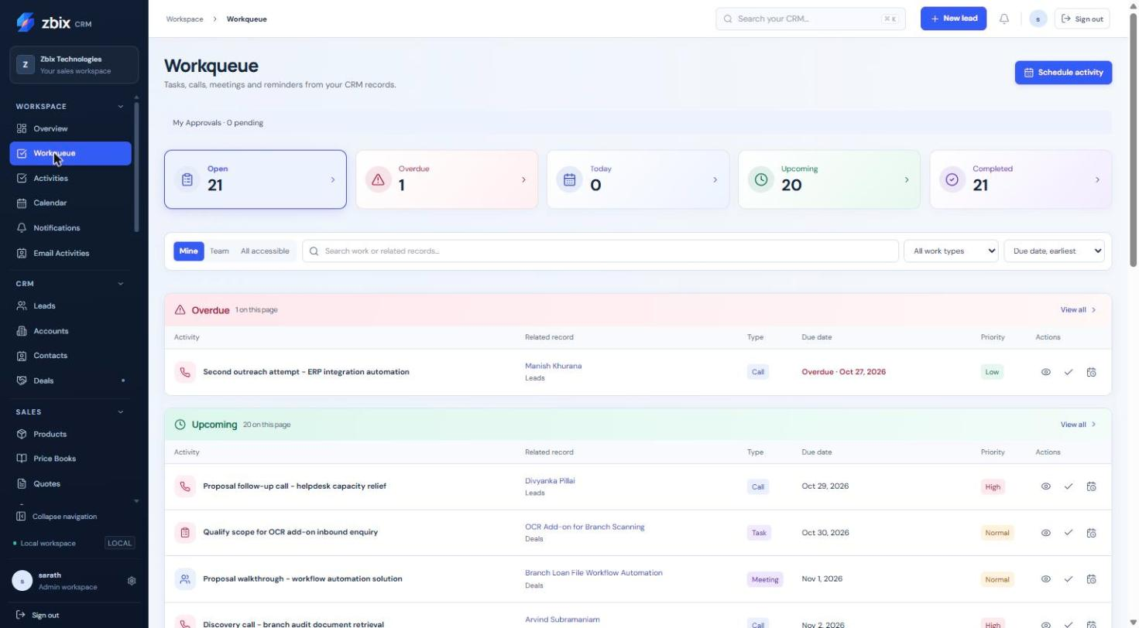
Figure 2 Task/call/meeting queue SS-002

Important considerations
- Completing a task is different from cancelling a scheduled job. Use the action shown for that source type.
- Meeting rescheduling moves its start/end and associated reminder together.
- Scope controls cannot reveal work outside the underlying record and module permissions.

Troubleshooting
- A work item has no action: your role may allow reading but not editing that source.
- An overdue item remains after work: verify the saved Activity status is Completed and refresh.
- A reminder is late: ask an administrator to check worker heartbeat and due-job age.
Related knowledge base articles: Record tasks calls and meetings; Plan meetings in Calendar; Review notifications and scheduled jobs; Read the Overview dashboard.

Record tasks calls and meetings
Zbix CRM 1.2.0 | Source reviewed | Reviewed 28 October 2026
Activities record customer-related work such as tasks, meetings, calls, visits and email activities. The activity list is the full log; Workqueue emphasizes what is due and Calendar emphasizes meetings.
Keep the outcome and next action alongside the customer relationship.

Before you begin
- Activity create/edit permission.
- Access to the related Lead, Account, Contact or Deal when associating work.

Procedure
1. Open Workspace > Activities and select Create activity, or use Schedule an activity on an accessible customer record.
2. Enter a concise Title and choose the Activity type. Select priority and the appropriate status: Open, In Progress, Completed or Cancelled.
3. Set the Due date. For a meeting, provide its start and end, timezone and location or supported HTTPS online-meeting reference.
4. Choose the related module and record, and record useful context in Description. Confirm the owner where assignment is allowed.
5. Save. Open the Activity after the work is performed and update its status and description with the result.
6. Use the list's search, status filter and Export control when a permitted activity extract is required.

Expected result
A dated, owned activity is visible in the log and, where applicable, Workqueue or Calendar.
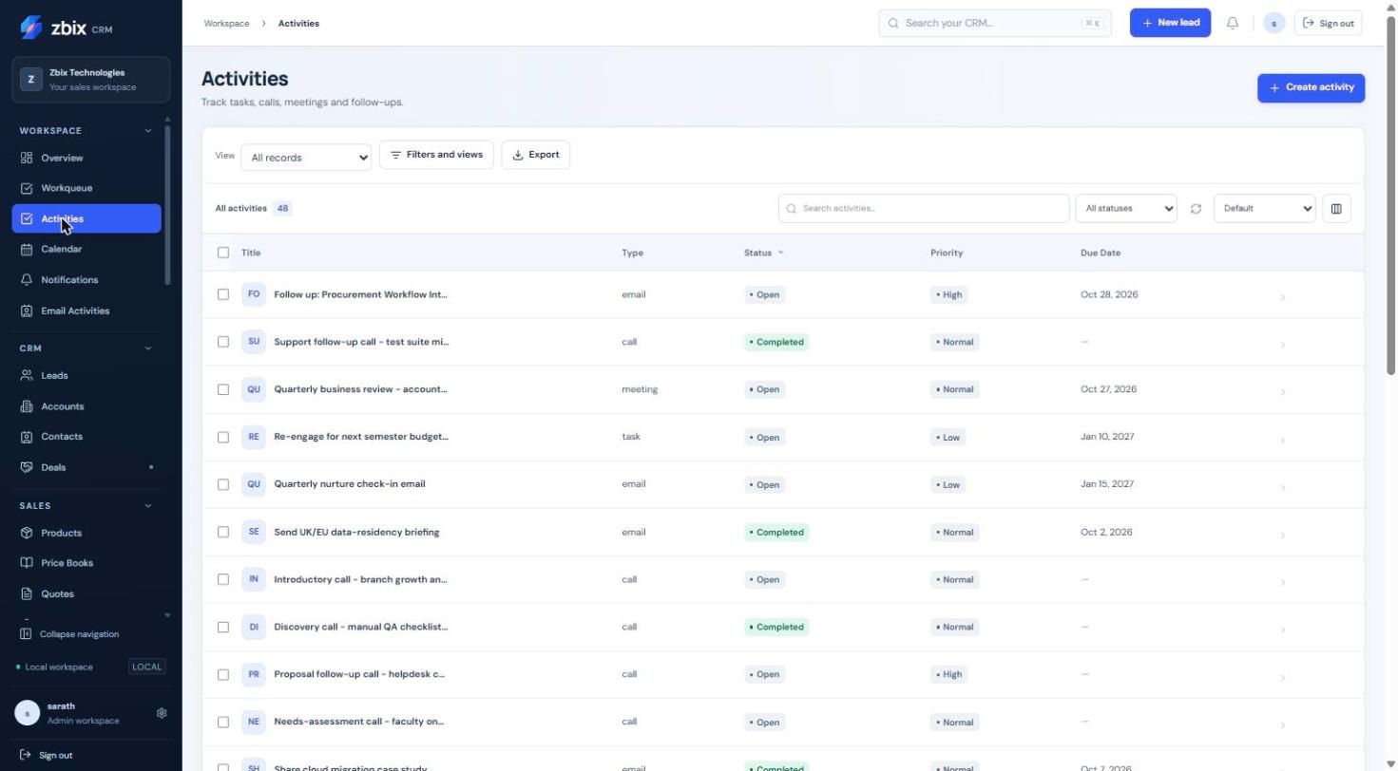
Figure 3 All activities list SS-003

Important considerations
- A meeting end must be later than its start. Ambiguous or nonexistent local times must be corrected rather than silently converted.
- The activity type email is a CRM work record; it does not itself submit an outbound email.
- Meeting reminders are bounded to 0-10080 minutes when the field is used.

Troubleshooting
- Meeting timing is rejected: correct the date, timezone and end time.
- An association fails: select a permitted record from the intended module.
- Export is unavailable: export requires its own grant and remains bounded to 10000 matching rows.
Related knowledge base articles: Plan meetings in Calendar; Manage your daily Workqueue; Create and send Email Activities; Create and update CRM records.

Plan meetings in Calendar
Zbix CRM 1.2.0 | Source reviewed | Reviewed 28 October 2026
Calendar displays CRM meeting Activities and, when a personal Microsoft 365 connection is configured, that user's private Outlook events. It offers Day, Week, Month and Agenda views.
Plan and review appointments without confusing private mailbox events with shared CRM records.

Before you begin
- Activity access for CRM meetings.
- A separately connected Microsoft 365 account and selected calendar mode for Outlook features.

Procedure
1. Open Workspace > Calendar. Choose Month, Week, Day or Agenda and use Previous, Today and Next to select the period.
2. Select New meeting. Enter the title, start/end, timezone, owner and related CRM record where relevant.
3. Review location and reminder settings, then save the meeting.
4. Open an existing CRM meeting to inspect or edit it. Change the timing deliberately and confirm the saved result in Calendar and Workqueue.
5. If Outlook events are visible, inspect their source before importing an event into CRM. Import is explicit and does not automatically associate a customer.
6. For a synchronization conflict or uncertain remote write, review the personal Microsoft 365 page before attempting another write.

Expected result
The CRM meeting uses the same Activity record in Calendar, Workqueue and record history.
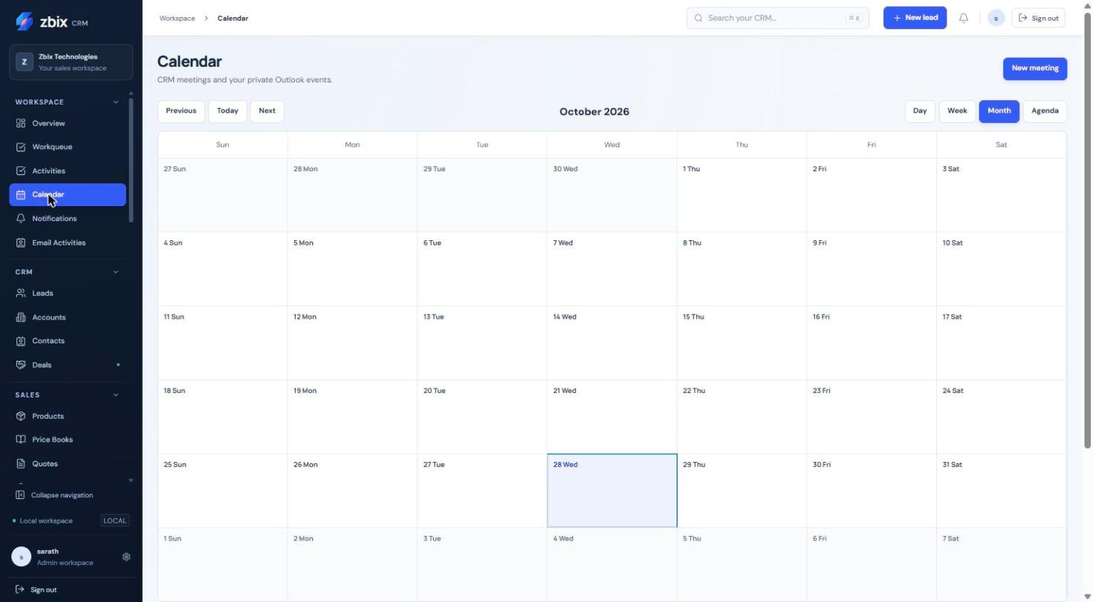
Figure 4 Month view calendar SS-004

Important considerations
- Connecting Microsoft 365 does not change CRM login. Outlook sync modes are configured separately.
- CRM-created Outlook events intentionally omit invitees; synchronization is not an invitation-delivery feature.
- A private Outlook event remains private until explicitly imported or associated under the available controls.

Troubleshooting
- No meetings appear: check the date range, selected view and Activity permissions.
- Outlook events are absent: inspect personal connection, selected calendar and sync mode.
- Conflict or Uncertain status: compare the remote and CRM records instead of repeatedly resubmitting.
Related knowledge base articles: Record tasks calls and meetings; Manage your daily Workqueue; Connect Microsoft 365 mail and calendar.

Review notifications and scheduled jobs
Zbix CRM 1.2.0 | Source reviewed | Reviewed 28 October 2026
Notifications and reminders provide an in-application inbox and a separate Scheduled jobs view. Notifications are messages already available to you; scheduled jobs describe work that is due to be executed by the background worker.
Acknowledge reminders and inspect the status of scheduled work.

Before you begin
- An authenticated account.
- Current permission to read the referenced CRM record or scheduled source.

Procedure
1. Open Workspace > Notifications. Review the unread count and select the notification list.
2. Open a notification's source record where a link is available. Mark it read after reviewing its message, or dismiss it using the available control.
3. Open Scheduled jobs to inspect pending work and execution status.
4. Where your role and job state allow it, reschedule or cancel the job through its dedicated action.
5. Refresh and verify the job's next time or terminal status. For persistent failures, provide the job identity and safe error text to your administrator.

Expected result
Your notification inbox reflects what you have reviewed and scheduled work shows its current execution state.
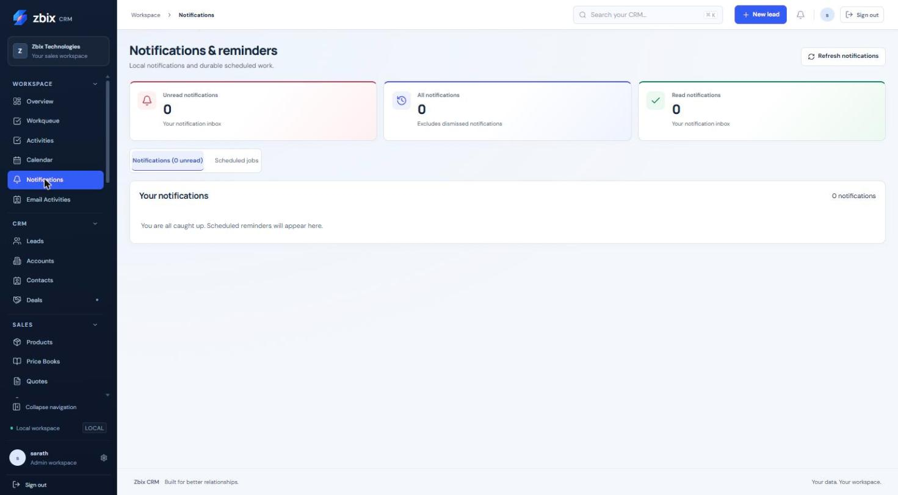
Figure 5 Notifications & reminders SS-005

Important considerations
- The captured inbox is empty; this is an example state, not evidence that notifications are unsupported.
- Scheduled execution rechecks current permissions and recipient availability.
- Daily/weekly interval jobs and business-calendar-based sales automation have different time semantics; follow the settings of the relevant rule.

Troubleshooting
- A notification cannot open its record: access may have changed since creation.
- A scheduled job is overdue: check worker processing through the administrator.
- A cancelled job still has history: cancellation preserves earlier execution evidence.
Related knowledge base articles: Manage your daily Workqueue; Record tasks calls and meetings; Workflows; Read System Health and verify service readiness.

Create and send Email Activities
Zbix CRM 1.2.0 | Source reviewed | Reviewed 28 October 2026
Email Activities stores drafts, reusable templates, related-record associations and attempt history. SMTP and Microsoft Graph are explicit delivery choices when configured. Local mock delivery is identified as simulated.
Send a reviewed message and understand the difference between a draft, a queued request and provider acceptance.

Before you begin
- Communication create/edit permission and access to the related CRM record.
- An enabled SMTP configuration or your connected Graph mailbox for real sending.
- An approved recipient and suitable attachments.

Procedure
1. Open Workspace > Email Activities and inspect Email provider status before composing.
2. Select Create email draft. Choose an accessible related record, recipient and optional template, then review the subject and rendered body.
3. Add permitted attachments where needed. Save email draft; saving does not send it.
4. Open the saved draft and select Send email. Choose the provider explicitly and review the recipient and any scheduled time before confirming.
5. Monitor Queued and the attempt history. Accepted means SMTP or Graph accepted the submission; verify delivery through the provider when delivery matters.
6. Use Cancel email activity only while the state allows it. Retry failed send is available for eligible definitely failed attempts; investigate an uncertain outcome first.

Expected result
The draft remains traceable to the CRM record, and sending produces durable status and attempt history.
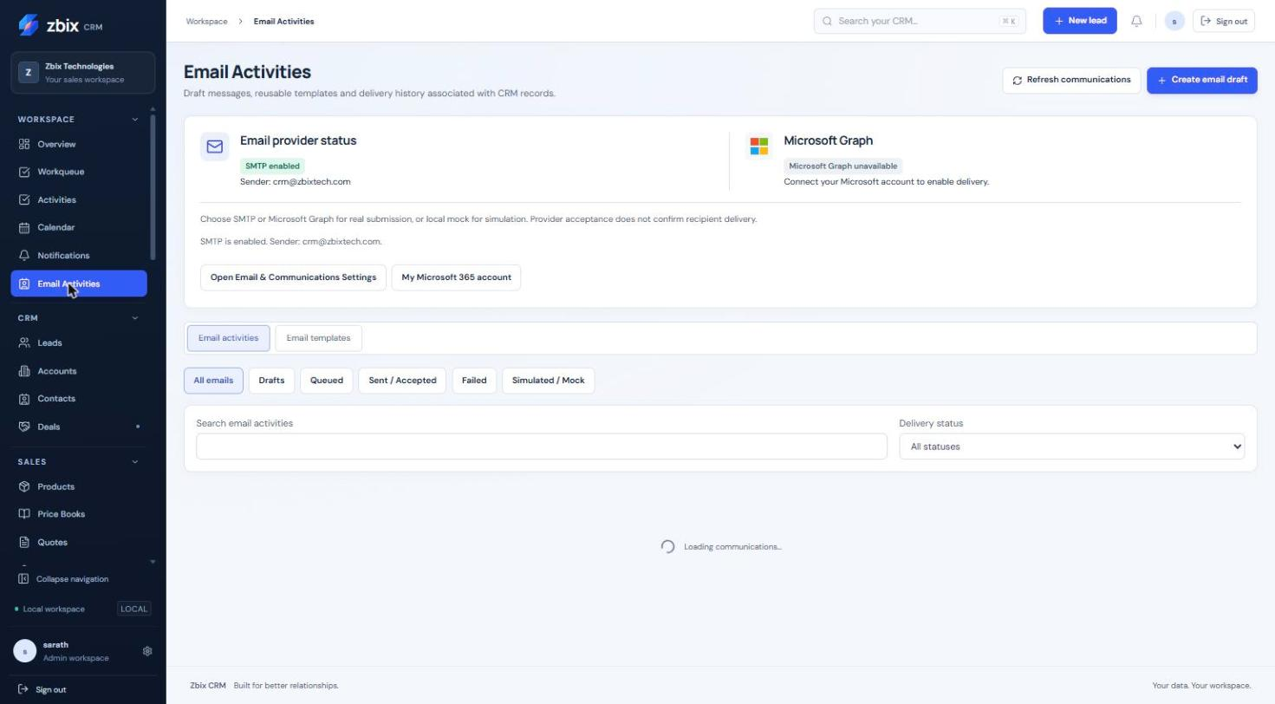
Figure 6 Email activities & provider status SS-006

Important considerations
- Changing a Quote to Sent does not send that Quote by email. Use an explicit communication action.
- A simulated/mock status records local processing only.
- Graph requires the sender to match the connected mailbox and recipient to match the related CRM record. Provider acceptance is not proof of inbox delivery.
- The supplied screenshot shows the provider panel but its message table is still loading; it illustrates provider controls only.

Troubleshooting
- SMTP disabled: ask the administrator to configure and test the provider.
- Graph unavailable: connect the personal Microsoft account with the required scope.
- Failed with uncertain outcome: inspect provider evidence before retrying to avoid duplicate messages.
Related knowledge base articles: Reuse email templates; Connect Microsoft 365 mail and calendar; Configure and use the scoped integration API; Record tasks calls and meetings.

Reuse email templates
Zbix CRM 1.2.0 | Source reviewed | Reviewed 28 October 2026
Email templates provide reusable message content with a bounded set of merge variables. A template can be private or shared with the organization. A draft stores its rendered content, so a later template change does not silently rewrite that draft.
Prepare consistent follow-up messages while reviewing each customer-specific result.

Before you begin
- Email-template create or edit permission.
- Access to the associated record when creating a message from the template.

Procedure
1. Open Email Activities and choose Email templates.
2. Select Create email template. Enter its name, subject and message body, then choose private or organization visibility and active state.
3. Insert only supported merge variables such as {{name}}, {{first_name}}, {{last_name}}, {{company}}, {{email}}, {{account_name}}, {{deal_name}} or {{sender_name}}.
4. Save the template. Create a new email draft using it and select the related CRM record.
5. Read the complete rendered subject and body, replace missing context and save the draft before the separate Send email action.

Expected result
The template is reusable within its visibility scope and the reviewed draft contains the intended customer text.

Important considerations
- Template names are bounded to 200 characters, subjects to 500 and bodies to 20000.
- Unknown variables and malformed merge expressions are rejected. Missing supported values may render blank, which requires human review.
- Sharing a template does not grant access to the records used to populate it.

Troubleshooting
- Template validation fails: use the supported variable names and a single-line subject.
- Blank customer text: populate the CRM field or enter appropriate wording in the draft.
- A shared template cannot be edited: another user may need both edit and manage-settings grants.
Related knowledge base articles: Create and send Email Activities; Create and update CRM records; Module Permissions.

Manage Leads
Zbix CRM 1.2.0 | Source reviewed | Reviewed 28 October 2026
A Lead represents a prospect before conversion into an Account, Contact and optionally a Deal. Lead details also expose revenue planning, business-process controls, sales automation activity and assignment history when those capabilities are enabled.
Qualify prospects, capture contact context and keep a clear follow-up before conversion.

Before you begin
- Lead view/create/edit permissions as appropriate.
- Assign permission to change the owner.
- Any custom data required by the published Lead layout.

Procedure
1. Open CRM > Leads and search by name, company or email. Review the status and rating before creating a duplicate.
2. Select Create lead. Complete Last name and Company, then enter First name, Email, Phone and Job title where known.
3. Choose Status, Rating and Lead source. Add Industry, Estimated value, Country, Website and Description as useful to qualification.
4. Review the Record owner and custom fields, then select Save lead.
5. Open the Lead to add a note, schedule an activity and review any business-process instructions. Update the status as qualification progresses.
6. When the prospect is ready, set Qualified and follow the separate conversion procedure. Do not manually set Converted.

Expected result
A prospect is saved with an owner, qualification state and actionable history.

Fields and controls
Field or control | Rule
Last name and Company | Required in the standard create form.
Status | New, Contacted, Qualified or Unqualified before conversion.
Rating | Hot, Warm or Cold.
Estimated value | Nonnegative numeric prospect estimate.
Lead source | Website, Referral, Event, Partner, Outbound or Other.

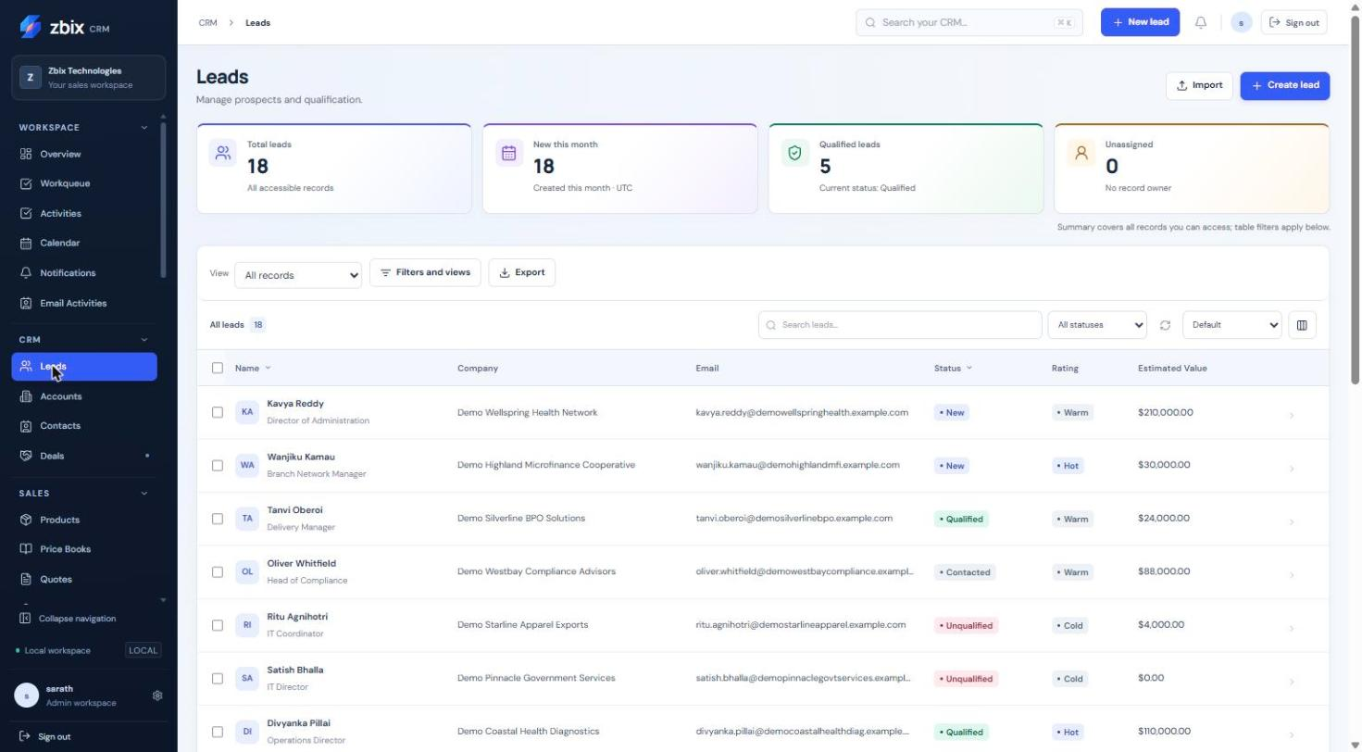
Figure 7 Leads list SS-007
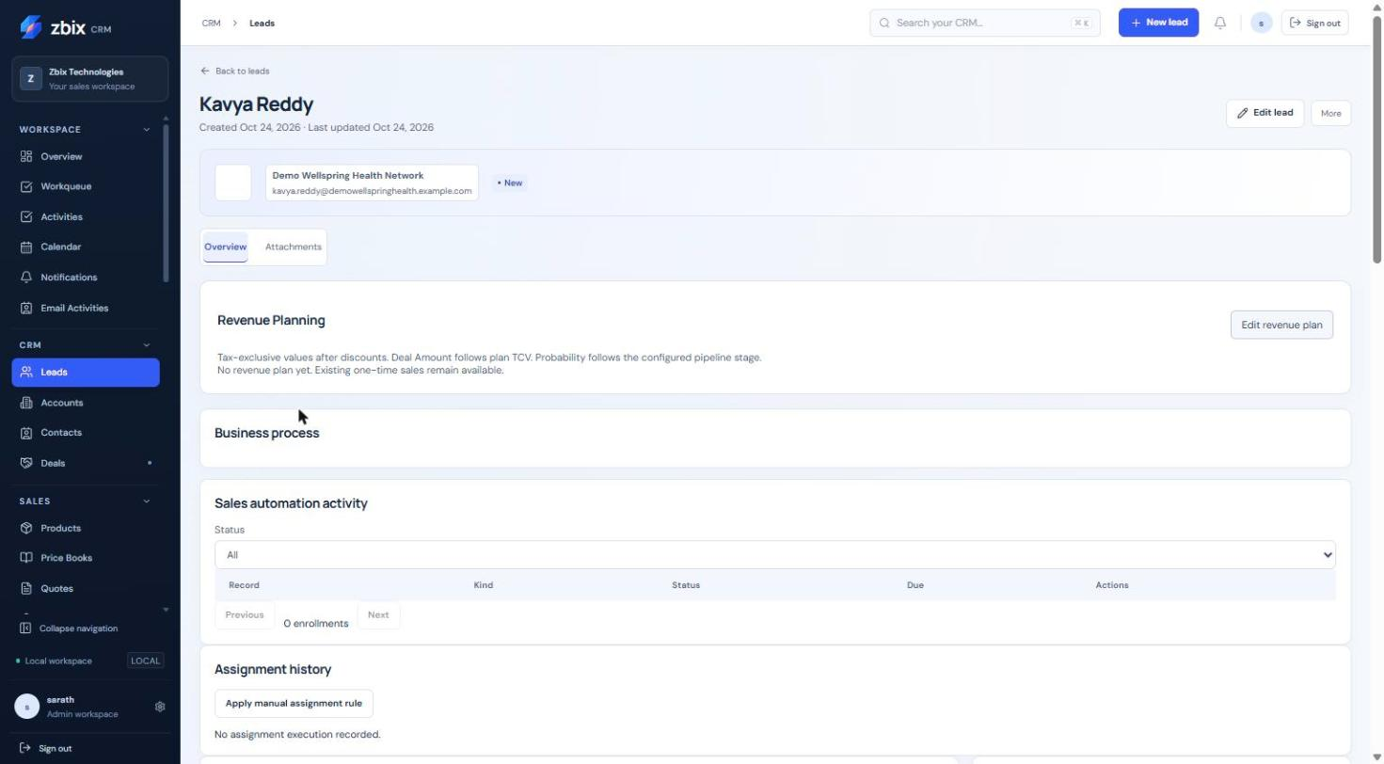
Figure 8 Lead detail record SS-008
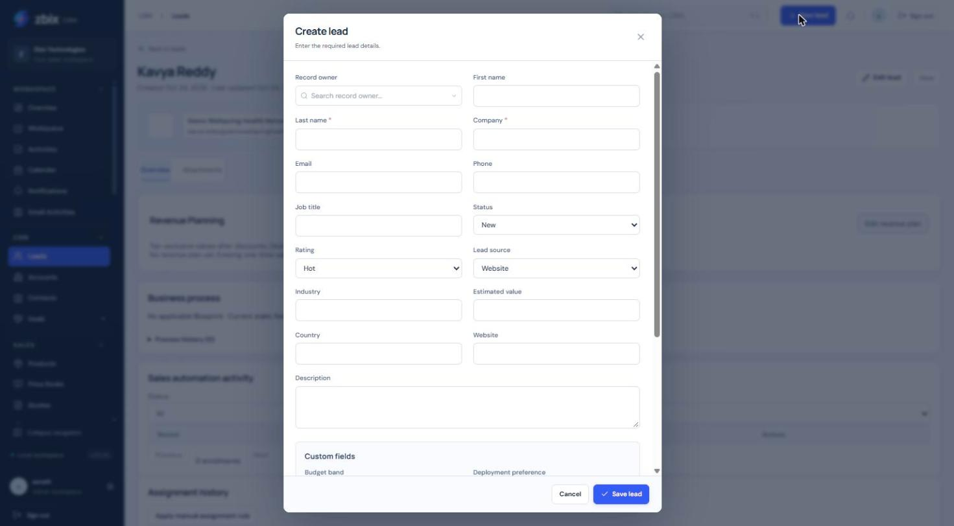
Figure 9 Create lead form SS-009

Important considerations
- The standard status choices are New, Contacted, Qualified and Unqualified; conversion sets Converted through a controlled operation.
- An email cannot duplicate another active Lead email in the organization, even if that other Lead is outside your visibility.
- The screenshot contains custom fields added for the demonstration workspace. Your published layout may differ.

Troubleshooting
- Cannot save: complete starred/custom required fields and correct invalid email or amount.
- Duplicate email: ask the owner or administrator to locate the existing Lead.
- Cannot edit a converted Lead: work in the linked Account, Contact or Deal instead.
Related knowledge base articles: Convert a qualified Lead; Record tasks calls and meetings; Manage Accounts; Manage Deals and pipeline stages.

Convert a qualified Lead
Zbix CRM 1.2.0 | Source reviewed | Reviewed 28 October 2026
Lead conversion connects a qualified prospect to an Account and Contact and can create or link a Deal. Matching existing records avoids parallel customer histories. The operation preserves conversion references on the Lead.
Move a qualified prospect into the customer and opportunity records used for ongoing sales.

Before you begin
- Lead status Qualified and permission to edit it.
- Permission to create any new Account, Contact or Deal and read any existing targets.
- Consistent Account, Contact and Deal relationships.

Procedure
1. Open the qualified Lead and choose Convert lead from the available record action.
2. Search for an existing Account. Select it, or enter a distinct new Account name when no suitable record exists.
3. Choose an existing Contact belonging to that Account or create a new Contact from the prospect details.
4. Choose whether to create a Deal, link an existing open Deal, or convert without one. An existing Deal must have the same Account and primary Contact.
5. For a new Deal review its name, currency, amount, pipeline, stage and expected close date. If the Lead has a revenue plan, review its transferred planning values.
6. Confirm conversion, then open the resulting Account, Contact and optional Deal to verify the links.

Expected result
The Lead becomes Converted and retains links to the resulting records. Repeating a completed conversion returns its existing result rather than creating another set.

Important considerations
- Existing target records cannot be edited as part of conversion. Correct them separately before retrying.
- A closed Deal cannot be selected. Its Account, primary Contact and currency must be coherent.
- Conversion is blocked while a Lead is governed by a Blueprint. Ask an administrator to review the applicable process; do not try to bypass it through another screen.

Troubleshooting
- Only qualified leads may be converted: update qualification through the permitted process first.
- Matching Account already exists: choose that Account rather than changing capitalization to evade the match.
- Lead changed: refresh and review the newest version before submitting again.
Related knowledge base articles: Manage Leads; Manage Accounts; Manage Contacts; Manage Deals and pipeline stages; Blueprints.

Manage Accounts
Zbix CRM 1.2.0 | Source reviewed | Reviewed 28 October 2026
Accounts represent customer and prospect organizations. Contacts, Deals, commercial documents and customer-specific price books can refer to an Account. The Account detail brings record information, attachments, notes and scheduled work together.
Maintain the organizational relationship that links people, opportunities and commercial transactions.

Before you begin
- Account view/create/edit access.
- Access to a parent Account if a hierarchy is required.

Procedure
1. Open CRM > Accounts and search the company before selecting Create account.
2. Enter Account name, then choose Account type: Customer, Prospect, Partner or Vendor.
3. Complete contact details, industry, country, currency and billing address as relevant. Select Active or Inactive status deliberately.
4. Use Parent account only when the organization belongs in a valid hierarchy. Save the Account.
5. Open its detail to add Notes and conversations, schedule an activity or review Attachments.
6. Create or update Contacts and Deals using this Account lookup so the relationships remain connected.

Expected result
The Account becomes the common organization reference for related customer work.
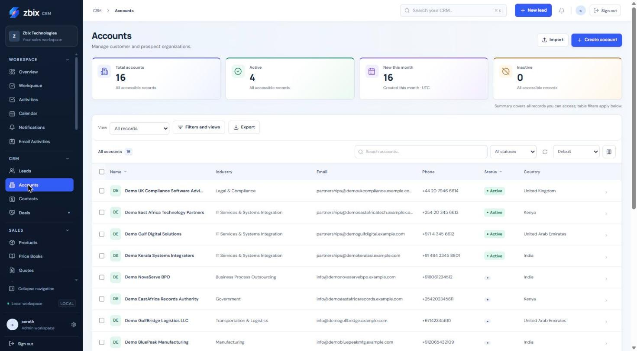
Figure 10 Accounts list SS-010
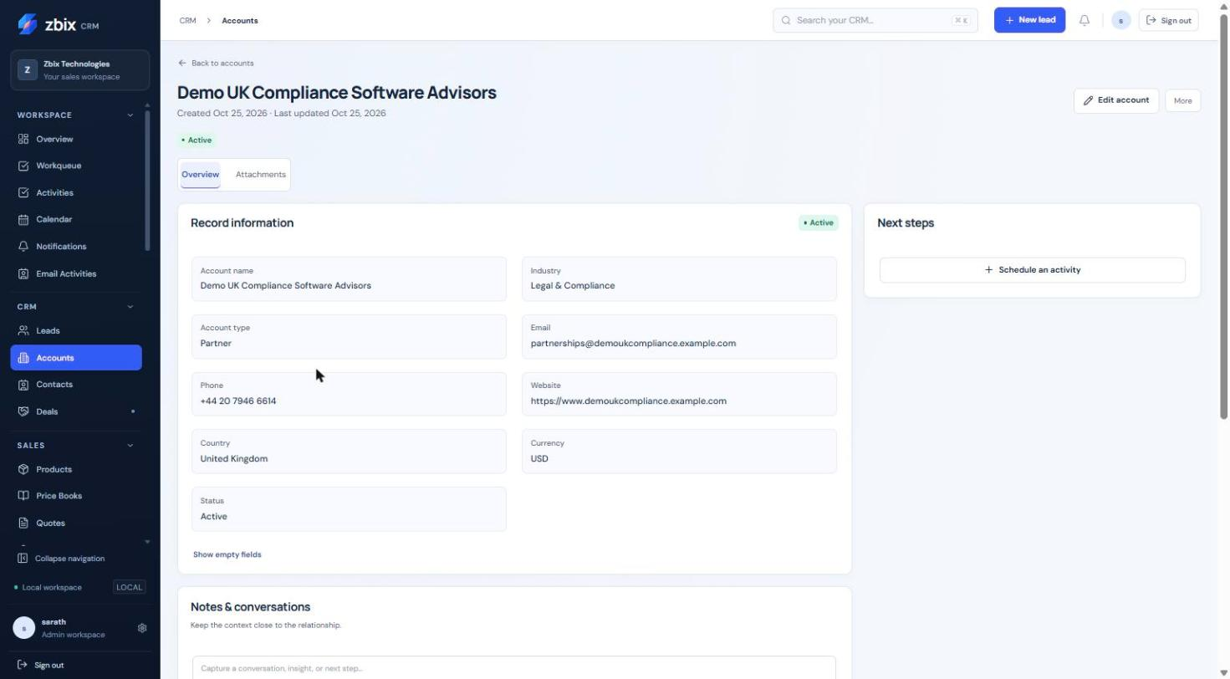
Figure 11 Account detail record SS-011

Important considerations
- An Account cannot be its own parent and circular hierarchies are rejected.
- Changing an Account address does not rewrite previously finalized commercial snapshots.
- Inactive is a business status; it is not the same as deleting a record or deactivating a user account.

Troubleshooting
- Hierarchy rejected: remove self-reference or a circular parent chain.
- Missing Contact on a Deal: verify that the Contact belongs to the selected Account.
- Record visible but not editable: your role may grant view without edit.
Related knowledge base articles: Manage Contacts; Manage Deals and pipeline stages; Configure and use Price Books; Attach and retrieve record files.

Manage Contacts
Zbix CRM 1.2.0 | Source reviewed | Reviewed 28 October 2026
Contacts store the people associated with customer Accounts. A Contact can hold role and communication details and be selected as the primary Contact on a Deal.
Keep the right person connected to the right organization and opportunity.

Before you begin
- Contact view/create/edit permission.
- Access to the Account you intend to link.

Procedure
1. Open CRM > Contacts and search the person's email or name.
2. Select Create contact. Enter Last name and optional First name, Email, Phone and Mobile.
3. Add Job title and Department so colleagues understand the person's role.
4. Select the Account through the lookup, review Description and custom fields, then save.
5. Open related Deals and choose this Contact only where its Account matches the Deal's Account.
6. Use notes or Activities to preserve communication context rather than repeatedly replacing identity fields.

Expected result
The Contact has a clear identity and, where selected, an Account relationship.
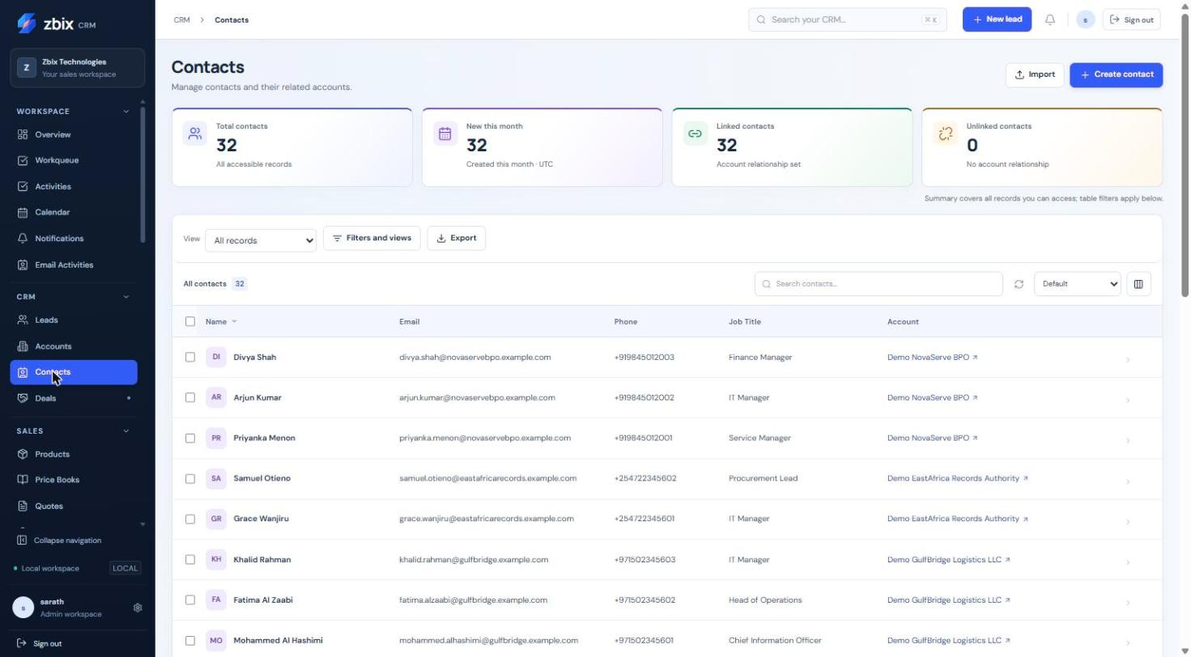
Figure 12 Contacts list SS-012

Important considerations
- Last name is required in the standard form. Email is validated when supplied.
- Duplicate email checks apply to active Contacts within the organization.
- The Contact list's linked/unlinked counters can help find records needing Account association.

Troubleshooting
- Duplicate email: locate or request access to the existing Contact.
- Contact cannot be selected for a Deal: correct the Account relationship.
- A name-only match is ambiguous: verify email and organization before linking.
Related knowledge base articles: Manage Accounts; Manage Deals and pipeline stages; Record tasks calls and meetings; Create and send Email Activities.

Manage Deals and pipeline stages
Zbix CRM 1.2.0 | Source reviewed | Reviewed 28 October 2026
Deals represent revenue opportunities. The module provides a pipeline board and a table view, while the detail page shows current stage, amount, expected close date and available next actions. Revenue plans and guided processes may add controls.
Keep opportunity value and stage aligned with actual sales progress.

Before you begin
- Deal view/create/edit access.
- Accessible Account and primary Contact where used.
- The active pipeline and its configured stage requirements.

Procedure
1. Open CRM > Deals. Select a pipeline and use Board or Table to review opportunities.
2. Select Create deal and enter Deal name and Amount. Choose the currency, Account, primary Contact and expected close date.
3. Select the permitted pipeline and initial stage. Complete any stage-required fields and save.
4. Open the Deal and use the stage control or available board action to propose a new stage.
5. Complete the required data or guided business-process transition. Record a won/lost reason when required by the configured stage.
6. Review stage history and the updated probability. If a revenue plan is attached, review that plan before trying to change the Deal amount.

Expected result
The Deal moves through a validated pipeline and retains stage history.
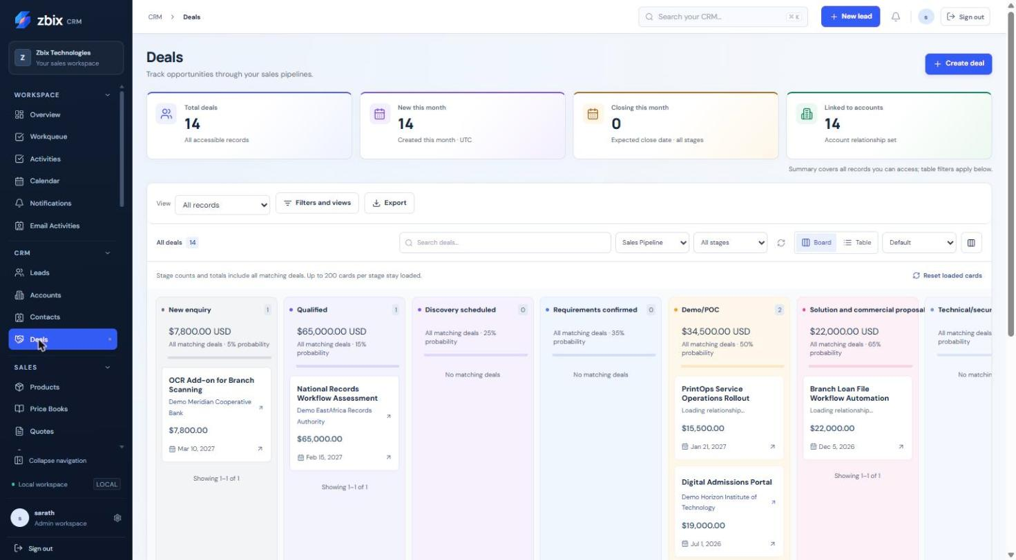
Figure 13 Pipeline board view SS-013
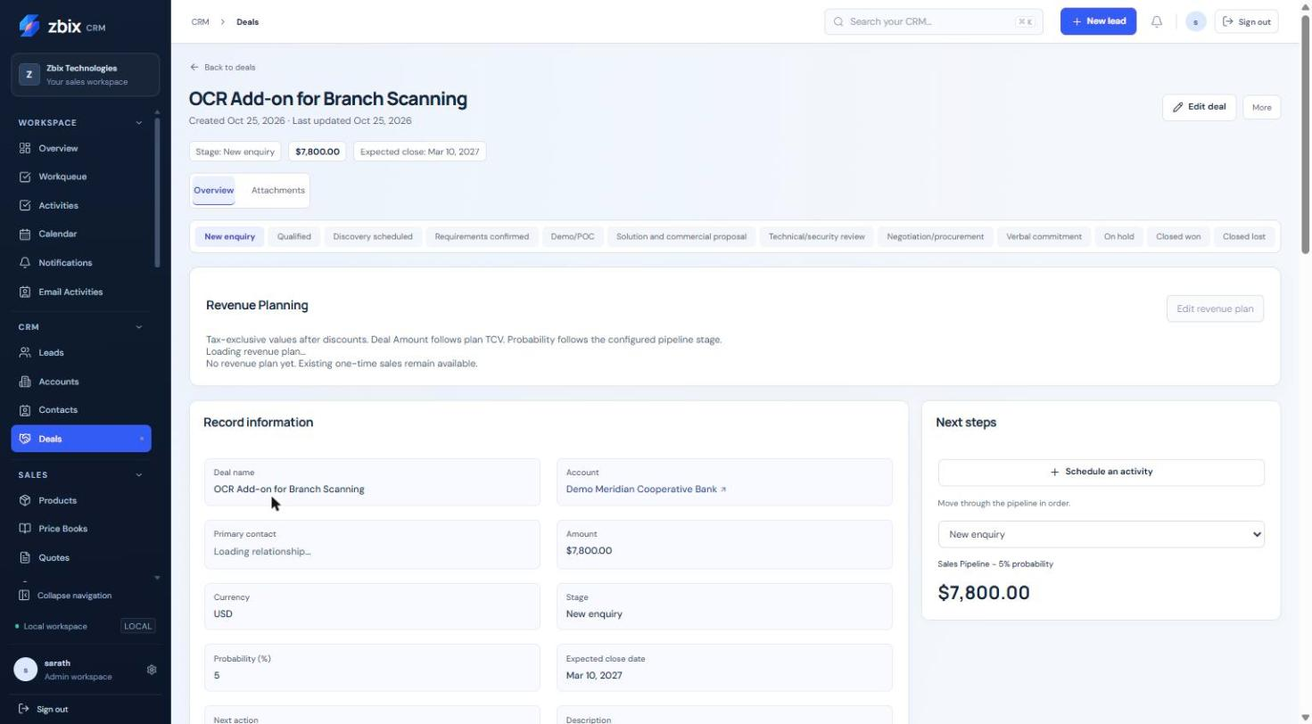
Figure 14 Deal detail record SS-014

Important considerations
- Stage labels and probabilities are organization configuration. The 12-stage demonstration pipeline is not a mandatory default.
- The standard currency selector and screenshot catalog currencies can differ; do not assume an automatic conversion between currencies.
- Board counts include matching Deals beyond the currently loaded cards. Refresh after concurrent changes.

Troubleshooting
- Stage change rejected: complete the configured required fields, allowed transition or Blueprint action.
- Contact mismatch: select a Contact from the Deal's Account.
- Amount cannot be edited as expected: inspect whether the revenue plan is authoritative.
- A card is missing: verify pipeline, stage, filters and loaded-card limits.
Related knowledge base articles: Configure Pipelines and stages; Prepare and manage Quotes; Convert a qualified Lead; Recurring Revenue; Blueprints.

Maintain the Products catalog
Zbix CRM 1.2.0 | Source reviewed | Reviewed 28 October 2026
Products provides reusable product and service references for sales documents. Each item has a product code, unit price, currency, unit of measure and active status. A Price Book can define a separate applicable commercial price.
Avoid inconsistent item naming and provide a controlled catalog for quotation preparation.

Before you begin
- Product create/edit permissions.
- The approved product code, price and currency for the catalog item.

Procedure
1. Open Sales > Products and search the product name or code.
2. Select Create product. Enter Product name and a unique Product code.
3. Enter the nonnegative Unit price, select Currency and enter Unit of measure and Category where useful.
4. Choose Active or Inactive, add the Description and save.
5. When preparing a Quote, select the Product and review the effective price source rather than assuming the catalog price always applies.
6. For customer-specific pricing, maintain a matching currency entry in Price Books.

Expected result
The Product is available for authorized selection and retains a unique organization-level code.
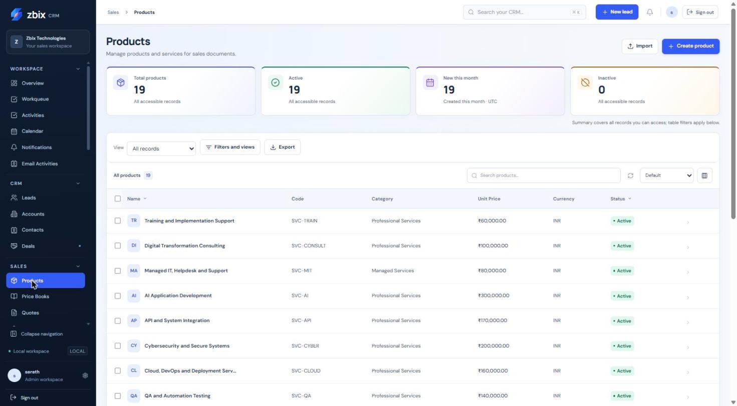
Figure 15 Products catalog SS-015

Important considerations
- The catalog screenshot shows INR values while the standard source form exposes a limited currency list. Existing imported data and configured forms may differ; confirm the intended currency with the administrator.
- Historical finalized document amounts do not recalculate when catalog prices change.
- An inactive catalog item should not be confused with deletion of past sales evidence.

Troubleshooting
- Duplicate product code: edit the existing Product or use the approved unique code.
- Currency mismatch on a Quote: select a compatible Product or price source; do not relabel the amount without review.
- A price differs: check the selected Price Book and effective date.
Related knowledge base articles: Configure and use Price Books; Prepare and manage Quotes; Create and progress Sales Orders; Import CSV and Excel records.

Configure and use Price Books
Zbix CRM 1.2.0 | Source reviewed | Reviewed 28 October 2026
Price Books group currency-specific product prices and can apply to all permitted customers or one Account. Book and item effective dates determine whether a price can be used. Quotation pricing retains its chosen source.
Maintain standard and negotiated customer pricing without changing historical documents.

Before you begin
- Price Book create/edit and approval grants as required.
- Access to the Products and optional customer Account.
- An approved currency and price-validity period.

Procedure
1. Open Sales > Price Books and select Create price book.
2. Enter Name, Currency and Status. Select Customer account only for a customer-specific book.
3. Set Effective date and Expiry date where needed, ensuring the date order is valid, then Save price book.
4. Open the book and add a Product price. Select the Product, unit, Unit price, Discount %, validity dates and status.
5. Save product price. Check for overlapping active price periods before adding another entry for the same Product.
6. Select the applicable book when preparing a Quote and review the resolved line price and provenance before saving.

Expected result
Authorized quotations can resolve applicable prices from the selected book while preserving the resulting snapshot.
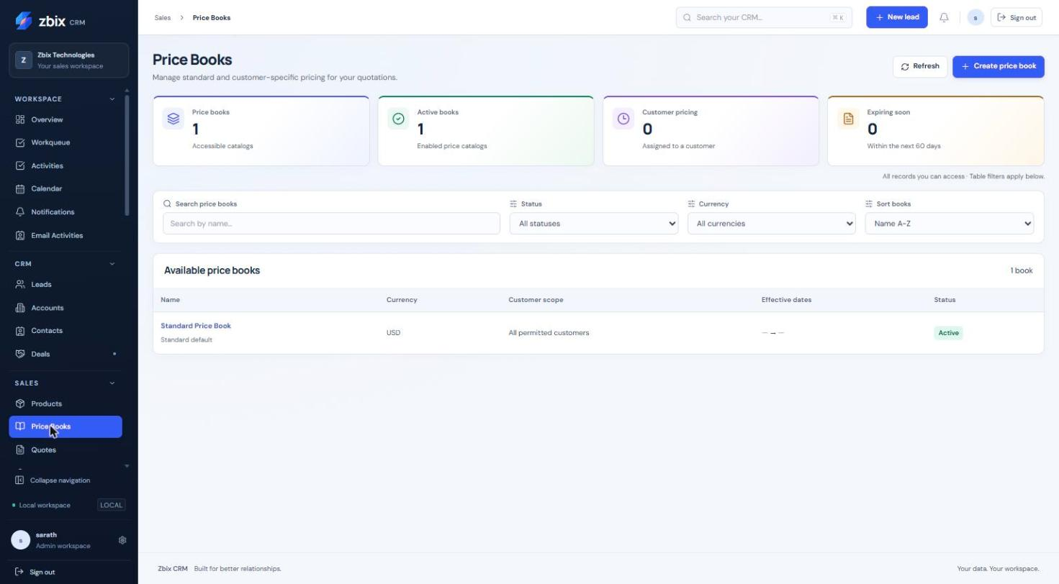
Figure 16 Price books list SS-016

Important considerations
- A customer-specific book applies only to its chosen Account. The system maintains the standard default book.
- Creation/content changes have separate action requirements; deactivation also requires the applicable delete grant.
- Price validity is evaluated with currency and customer applicability, not merely the displayed name.

Troubleshooting
- Price cannot be added: confirm Product visibility, matching currency and valid date range.
- Overlapping price error: revise the effective periods or deactivate the superseded entry through the permitted action.
- Unexpected quote price: check customer, book, issue/effective date and the saved line source.
Related knowledge base articles: Maintain the Products catalog; Prepare and manage Quotes; Manage Accounts; Module Permissions.

Prepare and manage Quotes
Zbix CRM 1.2.0 | Source reviewed | Reviewed 28 October 2026
Quotes combine customer details, priced line items and controlled status decisions. Revisions preserve the commercial and customer snapshot used at each stage, so a later catalog or address change does not rewrite a finalized quotation.
Prepare a customer offer, obtain approval where required and preserve the accepted version for order conversion.

Before you begin
- Quotation create/edit permissions and approval permission for approval decisions.
- Accessible Account, Deal, Products and Price Book as applicable.
- A consistent currency across the commercial relationships.

Procedure
1. Open Sales > Quotes and select Create quote. Enter the title, customer/Deal association, currency, valid-until date and terms.
2. Add the line items and review quantities, unit prices, discounts, tax and totals. Select the intended price source and document design where available.
3. Save the Draft before changing its status. Review the generated PDF and correct the draft if necessary.
4. Use Quote status and the review/comment control for the allowed lifecycle action. Submit Pending Approval when review is required and let an authorized approver record the decision.
5. Record Sent and the eventual Accepted or Rejected outcome using the permitted transition. Sending the document externally is a separate communication action.
6. For changes to finalized commercial terms, choose a new draft revision. Convert only the current Accepted revision into a Sales Order.

Expected result
The quotation retains a versioned offer and decision history, with PDF output for the selected revision.
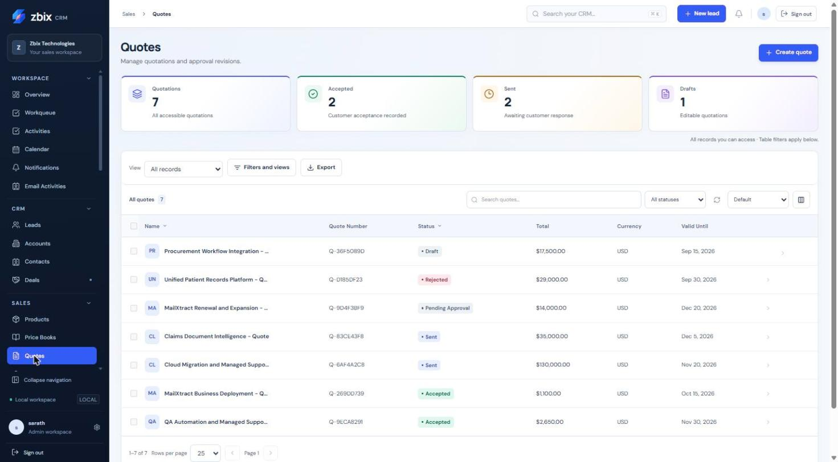
Figure 17 Quotes list SS-017

Important considerations
- Quotes require 1 to 100 line items with positive quantities and valid nonnegative monetary values.
- Save financial edits separately from status decisions. Finalized commercial terms cannot be edited in place.
- Quote Sent is a business state and does not transmit email.
- A previous revision remains available for review; the current revision drives new order conversion.

Troubleshooting
- Invalid transition: use the next action available for the current status.
- Commercial terms are immutable: create a new draft revision.
- Currency/relationship error: align Quote, Deal, Account and Product/price source.
- PDF differs from the current catalog: historical snapshots intentionally retain the earlier offer.
Related knowledge base articles: Configure and use Price Books; Create and progress Sales Orders; Design customer document templates; Create and send Email Activities.

Create and progress Sales Orders
Zbix CRM 1.2.0 | Source reviewed | Reviewed 28 October 2026
Sales Orders capture an accepted commitment and its fulfillment progress. An order can be entered as a draft or converted from the current accepted quotation revision. Confirmation freezes its commercial snapshot.
Move an accepted quotation into fulfillment and create the invoice from a controlled order.

Before you begin
- Sales Order create/edit access; approve permission for confirmation.
- Invoice create access for the later invoice step.
- Consistent customer, Deal and currency relationships.

Procedure
1. From an Accepted Quote, choose the order-conversion action and review the resulting draft. Alternatively, open Sales > Sales Orders > Create sales order.
2. For a manually created draft, complete the name, customer, currency, order date, delivery date and line items, then save.
3. Review the customer and financial snapshot and PDF design. Confirm the order through the status action when approved for fulfillment.
4. Progress Confirmed to Processing and then Fulfilled as the work occurs.
5. Choose the invoice action on a Confirmed, Processing or Fulfilled order. Review invoice and due dates and create the draft invoice.
6. If cancellation is required, supply a reason. Resolve an active invoice before cancelling the order.

Expected result
The order keeps its source and status history; invoice creation links back to that order.
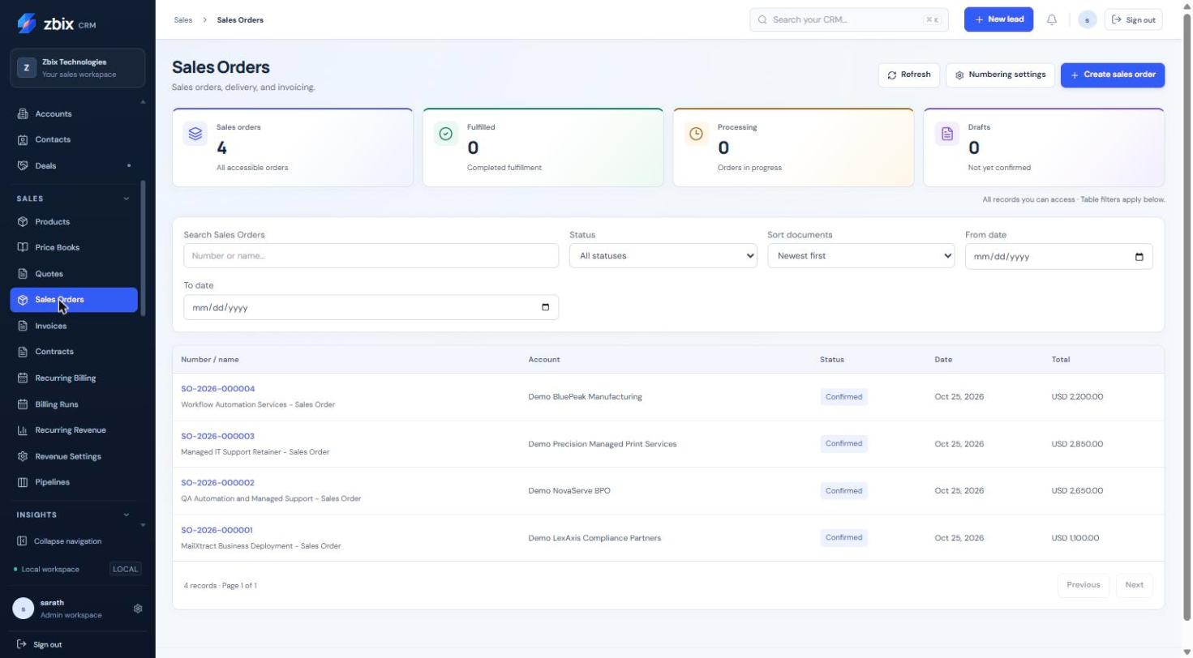
Figure 18 Sales orders list SS-018

Important considerations
- A quotation-derived snapshot cannot be edited in place, even while the order is Draft; amend through a new quotation revision.
- Confirmed financial snapshots are immutable. Order transitions are Draft to Confirmed/Cancelled, Confirmed to Processing/Cancelled, and Processing to Fulfilled/Cancelled.
- Conversion retry returns the existing order. An order has one invoice link; voiding does not authorize an automatic replacement.

Troubleshooting
- Cannot confirm: check approval permission and current status.
- Cannot cancel: an active invoice must first be resolved through its controlled workflow.
- Invoice action unavailable: confirm the order and check invoice permissions.
- Delivery date error: delivery cannot precede the order date.
Related knowledge base articles: Prepare and manage Quotes; Issue Invoices and record payments; Design customer document templates; Contracts.

Issue Invoices and record payments
Zbix CRM 1.2.0 | Source reviewed | Reviewed 28 October 2026
Invoices are created from eligible Sales Orders or recurring billing runs. Their Draft, Approved, Issued and Voided lifecycle is separate from the displayed payment state. Payment records are internal records requiring reconciliation.
Review an invoice, issue its controlled number and record a payment reference without treating the CRM as a bank settlement service.

Before you begin
- Invoice view/edit access and approve permission for lifecycle decisions and payment entry.
- An eligible Sales Order or generated recurring-billing invoice.
- Approved payment evidence before recording money.

Procedure
1. Open the source order or billing run to create/find its draft invoice, then open Sales > Invoices.
2. Review dates, terms, customer, currency and line totals. Only draft dates, payment terms and notes can be edited through the invoice editor.
3. Approve the draft, then Issue the approved invoice after final review. Issuance allocates its invoice number and captures its document artifact.
4. Download or preview the PDF. Transmit it only through an explicitly chosen communication process.
5. For an issued invoice, choose the payment action. Enter a positive amount within the outstanding balance, the payment date and a meaningful reference.
6. Save and inspect payment history and the derived Partially Paid/Paid/Overdue display. Reconcile the entry against the actual payment source.

Expected result
The invoice preserves its issued snapshot and append-only payment history.
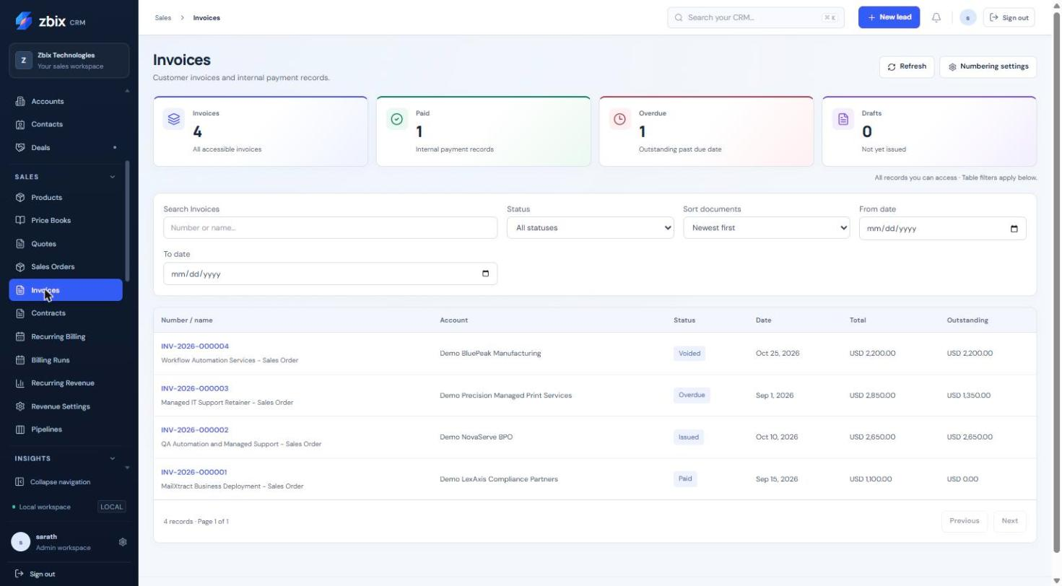
Figure 19 Invoices list SS-019

Important considerations
- Recording a payment does not charge a customer, contact a bank or prove settlement.
- Invoices with recorded payments cannot be voided. Credit notes, payment deletion and reversal workflows are not provided by this lifecycle.
- A return from Approved to Draft or a void requires a reason. An issued number is not reused.
- Overdue and paid labels are derived from dates and recorded balances; they are not a separate editable financial snapshot.

Troubleshooting
- Payment exceeds balance: compare amount, currency precision and earlier payment history.
- Cannot void: check for recorded payments and escalate through your finance process.
- Number absent: the invoice may still be a draft or approved but unissued.
- Wrong terms on an issued invoice: do not overwrite the stored snapshot; obtain an approved correction process.
Related knowledge base articles: Create and progress Sales Orders; Billing Runs; Recurring Billing; Design customer document templates.

Analyze performance with Reports
Zbix CRM 1.2.0 | Source reviewed | Reviewed 28 October 2026
Reports provides scoped sales performance with date, owner, team, pipeline and stage filters. KPI cards and trend/stage charts help compare pipeline, won/lost results, conversion and overdue work.
Answer a sales-performance question with consistent scope and currency definitions.

Before you begin
- Reporting and underlying source-module access.
- Export permission when downloading supporting data.

Procedure
1. Open Insights > Reports and choose an available performance view.
2. Set the Date range or explicit UTC period, then choose owner, team, pipeline and stage as needed.
3. Select Apply filters and review the active filter count before reading results.
4. Choose the display currency and inspect each KPI, closed-won trend and pipeline-stage chart.
5. Use the related Deal or Activity views to investigate records behind the result.
6. Save a reusable definition in Saved Reports when the same question needs regular review.

Expected result
The report reflects current authorized records and the selected filters.
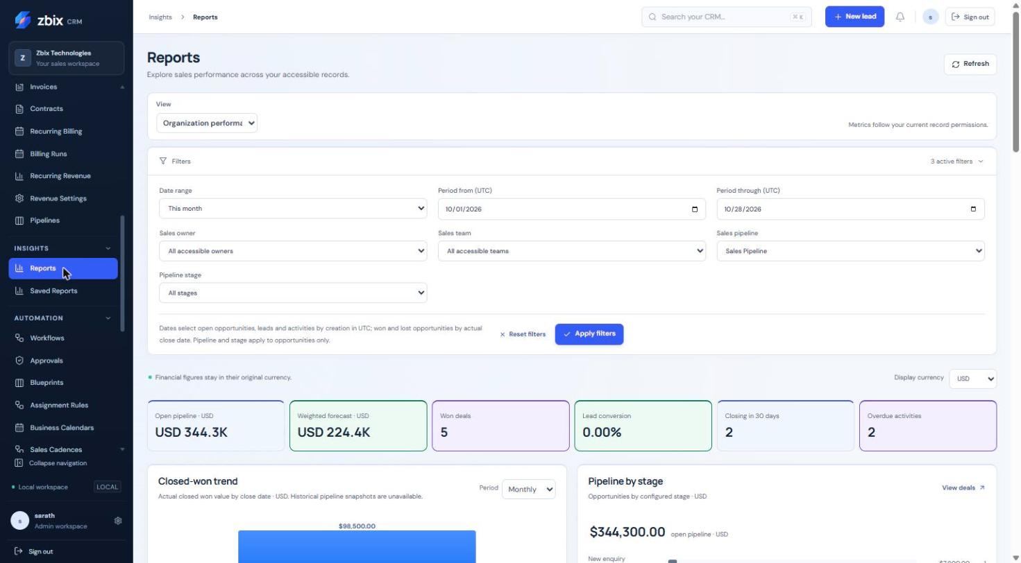
Figure 20 Reports dashboard SS-027

Important considerations
- Currencies remain separate; the report does not apply foreign-exchange rates.
- Won/lost analysis uses actual close date while other cohorts can use creation date. Read each metric's explanatory text.
- Team results can overlap. Historical pipeline snapshots are not implied by a closed-won trend.
- CSV exports reject more than 10000 matching records; narrow the query instead of expecting truncation.

Troubleshooting
- Report differs from a list: compare scope, dates, status, source and table filters.
- An owner or team is unavailable: its reporting scope may not be granted.
- An export fails: check both report/source export permissions and the matching-row limit.
Related knowledge base articles: Read the Overview dashboard; Create and share Saved Reports; Manage Deals and pipeline stages; Module Permissions.

Create and share Saved Reports
Zbix CRM 1.2.0 | Source reviewed | Reviewed 28 October 2026
Saved Reports stores reusable report definitions rather than frozen copies of all source data. Opening or exporting a report evaluates the current viewer's access and current records.
Reuse a consistent sales question and share its definition with the appropriate audience.

Before you begin
- Saved-report create/edit access.
- View access to the source module; export access to both the report and source when exporting.
- An eligible team for team sharing.

Procedure
1. Open Insights > Saved Reports and select Create report.
2. Choose the report type and name. Configure the available filters, columns, sorting and grouping for the question.
3. Choose Private, Team or Organization visibility as permitted. Select a team when using Team visibility.
4. Select Preview report and inspect both detail rows and grouped totals. This preview has not yet saved the definition.
5. Save the report, reopen it and verify the result. Use Duplicate when adapting a shared definition for a different question.
6. Use Export report CSV when permitted. Review the selected definition and limits before distributing the extract.

Expected result
The report definition is saved and available to its intended audience without expanding record access.
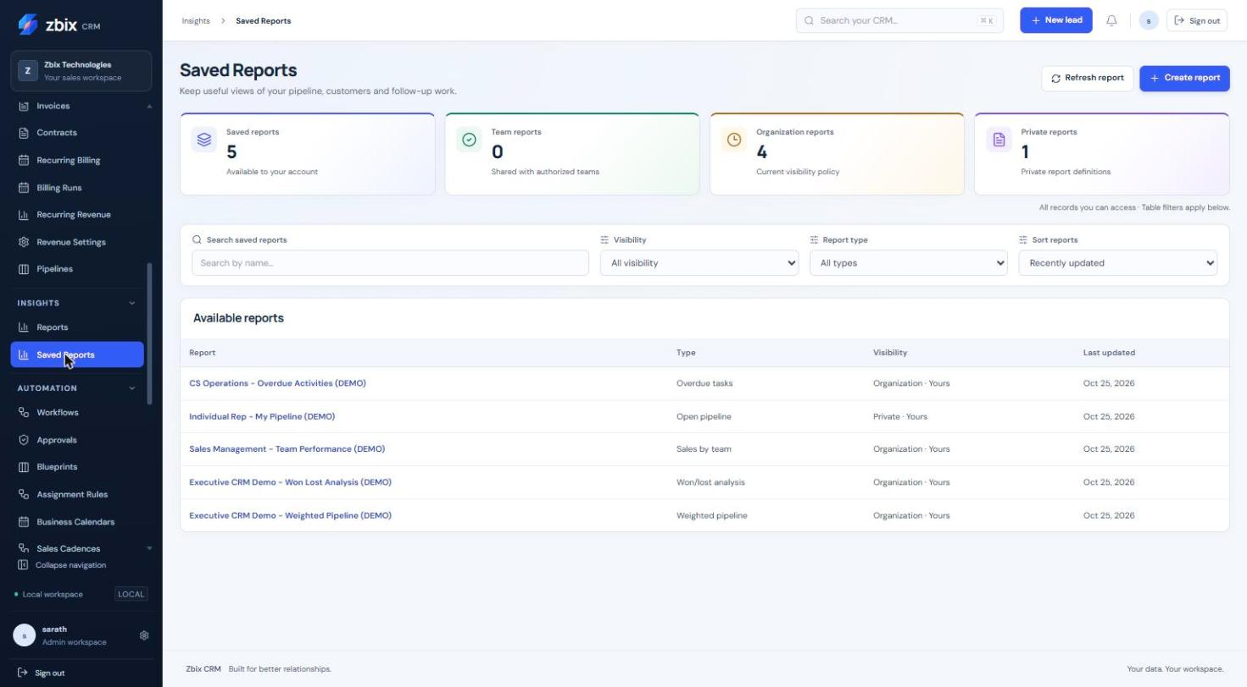
Figure 21 Saved reports list SS-028

Important considerations
- The demonstration library includes overdue tasks, open pipeline, team performance, won/lost and weighted pipeline definitions.
- A shared report can yield different data for different viewers because visibility is enforced again.
- Report edits use version checks. A duplicate starts as a private copy.

Troubleshooting
- Sharing option unavailable: check the current report grants and team membership.
- Empty results for another user: confirm source permissions and filters rather than widening all access.
- Preview differs after saving: records or permissions may have changed; inspect the saved filters.
Related knowledge base articles: Analyze performance with Reports; Save filtered record views; Module Permissions.

Save filtered record views
Zbix CRM 1.2.0 | Source reviewed | Reviewed 28 October 2026
Saved views preserve list filters, selected columns and sorting for repeated record work. Private, team and organization visibility determines who can use the view definition, while record and field permissions still determine the returned data.
Create a repeatable operational list such as qualified Leads or open Deals assigned to a team.

Before you begin
- Access to the record module and the saved-view action.
- A permitted sharing scope.

Procedure
1. Open the target record list and choose Filters and views.
2. Build the required conditions using the available fields and operators. Keep the query focused on the business task.
3. Select the useful columns and sort order, then preview the list results.
4. Save the view with a meaningful name and choose the allowed private, team or organization visibility.
5. Select the saved view from the list's View control. Use favorite/default options where offered.
6. Duplicate the definition for another purpose rather than silently changing a shared view used by colleagues.

Expected result
The named view reapplies its definition to the current authorized data.

Important considerations
- Hidden custom fields remain hidden even when referenced by a shared definition.
- A view is a query, not a frozen audit report.
- Exports use the authorized query and remain subject to export limits.

Troubleshooting
- A saved filter stops working: a field may have been retired or its permissions changed.
- Unexpected empty result: reset filters, check owner/team conditions and verify the data type used by the condition.
Related knowledge base articles: Navigate lists and records; Create and update CRM records; Analyze performance with Reports; Fields and Layouts.

Attach and retrieve record files
Zbix CRM 1.2.0 | Source reviewed | Reviewed 28 October 2026
Attachments belong to a CRM record and inherit access checks from that parent as well as attachment permissions. Uploading a file and making it available for download are separate steps when scanning is required.
Keep supporting customer files associated with the right record and understand quarantine status.

Before you begin
- Access to the parent CRM record.
- Attachment create permission for upload or view permission for retrieval.
- An allowed file within the configured size limit.

Procedure
1. Open the customer record and select Attachments.
2. Choose the upload control, select the intended file and review its name and size before submitting.
3. Wait for metadata and scan status to appear. Refresh after background scanning where necessary.
4. Download only when the application makes the file available. Confirm that you have opened the intended record before sharing a downloaded copy.
5. If the file is blocked, inspect its status and ask an administrator to review the configured scanner and policy.
6. Use the delete action only when authorized and after confirming that the correct file is selected.

Expected result
The file is stored privately with its record association and controlled availability.

Important considerations
- New files may remain pending or unavailable until scanning completes; a successful upload is not a clean-scan result.
- Configured upload limits default to 10 MiB with a bounded maximum. The installation may use a stricter limit.
- Removing access to the parent record can also remove attachment access.
- Soft deletion and byte-retention cleanup are operational concerns; do not promise immediate physical erasure.

Troubleshooting
- Upload too large: use an approved smaller file or ask about the installation limit.
- Download blocked: inspect scan state; do not work around a quarantine warning.
- File not found: confirm the parent record, current access and deletion status.
Related knowledge base articles: Create and update CRM records; Read System Health and verify service readiness; Set up authenticator protection.

Frequently asked questions
Zbix CRM 1.2.0 | Source reviewed | Reviewed 28 October 2026
These answers address common differences between what users see in a list, what a document status means and which actions require administrative help.
Resolve frequent onboarding questions before changing data or requesting broader access.

Before you begin
- Access to your own workspace.

Procedure
1. If a colleague sees more records, compare effective role and own/team/organization visibility. Ask for the specific access needed for your work.
2. If a saved view or report is shared, remember that it shares a definition and still respects the viewer's record and field permissions.
3. If a Quote is Sent, verify whether an Email Activity was separately queued. The quote status alone does not send mail.
4. If an email is Accepted, inspect provider history when delivery is important. Accepted is submission acknowledgment, not inbox receipt.
5. If a payment is recorded, reconcile it with the actual transaction. CRM payment history does not charge the customer.
6. If a record or commercial document is locked, use its revision, transition or approval workflow rather than creating an unlinked duplicate.

Expected result
You can distinguish expected product controls from problems that need support.

Important considerations
- An empty screenshot or list does not mean a capability is missing.
- A role title is insufficient to infer permissions; inspect effective access.
- The documentation describes the release baseline, while your organization controls published layouts, stages and enabled capabilities.

Troubleshooting
- Still blocked: record the page, operation, time and exact safe error message. Include a redacted screenshot and ask your administrator to verify access and version.
- Do not attach passwords, authentication codes, tokens, private keys or unredacted configuration to a support request.
Related knowledge base articles: Navigate lists and records; Module Permissions; Create and send Email Activities; Issue Invoices and record payments; Collect useful support evidence.

Contracts
Zbix CRM 1.2.0 | Source reviewed | Reviewed 28 October 2026
Contracts store versioned commercial commitments for a customer account, including recurring, one-time or mixed revenue lines. Contract details separate Overview, Commercial Terms, Billing, Documents, Activities, History and Renewal.
Use a Contract to turn a won Deal’s revenue plan into a controlled agreement, or to record a direct agreement for an existing customer. Draft creation and activation are separate actions.

Before you begin
- The user has Contracts create/view permissions and access to the customer account and related records.
- Activation requires approval authority. Billing configuration requires Billing manage_settings and Invoice create; Review Required and Automatic Issue additionally require Invoice approval.
- The agreement creation form loads defaults through Revenue Plans view permission; include that grant for users creating agreements.

Procedure
1. Open Sales > Contracts and select Create Contract. Alternatively, open a won Deal with an account and saved revenue plan and select Create Contract from Won Deal.
2. Enter Agreement name and Customer account. Optionally select Contact and Quote, enter General and termination terms, Cancellation notice days and Invoice grouping preference.
3. Select Revenue model, Currency, Expected service start and Term type. A Fixed Term needs a duration or exclusive end; Ongoing Until Cancelled can include minimum commitment months.
4. Add Revenue lines. For each line enter description, quantity and unit price, select Charge type and Every N months for recurrence. Expand Line dates, discount and tax treatment for optional product, dates, discounts and inclusive/exclusive tax.
5. Select Preview agreement forecast and review the amounts and service-month breakdown. Then select Create draft agreement.
6. Review the draft and custom fields under Overview. Use the authorized lifecycle action to activate when the terms are approved.
7. In Commercial Terms, enter a revised plan, Effective date and Amendment reason. Select Validate and preview amendment, review Future financial effects, then Confirm commercial revision.
8. Use Documents and Activities to associate existing customer files or activities. Manage customer files opens the normal attachment service; Create linked task makes an associated follow-up.

Expected result
The agreement retains its commercial versions and audit history. Financial changes affect eligible future periods while preserving protected invoice history.

Fields and controls
Field or control | Rule
Agreement name | Required
Customer account | Required accessible Account
Currency | Configured commercial currency; immutable after creation
Term | Fixed up to 120 months or ongoing until cancelled
Revenue line interval | 1-36 months
Plan lines | At most 100; unique line identities
End date | Exclusive; after service start
Contact | Optional; must belong to customer Account

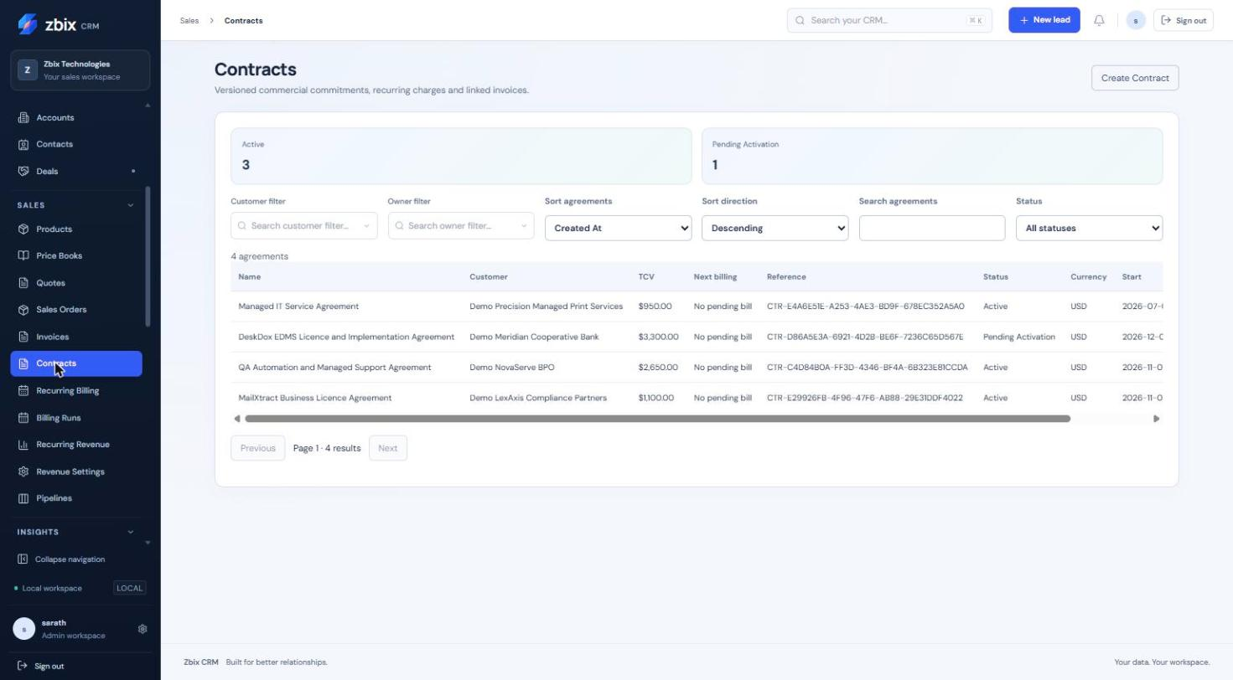
Figure 22 Contracts list SS-020

Important considerations
- Recurring unit price is the charge for the selected interval. For an annual 1,200 charge, use unit price 1,200 and interval 12; normalized MRR is 100 before applicable adjustments.
- End dates are exclusive. Fixed terms are bounded to 120 months; line intervals are 1-36 months and a plan permits at most 100 lines.
- Currency is immutable once the agreement exists. Contacts must belong to the account; related Quotes/Orders must match customer and currency.
- An ongoing agreement shows Ongoing - No Fixed TCV. Its bounded forecast is not lifetime committed value.
- Removing an association preserves the underlying customer file or activity.

Troubleshooting
- Create from won Deal fails: verify a won stage, linked account and saved revenue plan.
- Amendment is rejected: preserve line identities/start anchors and use an eligible unbilled boundary; do not alter an issued invoice to reflect new pricing.
- Concurrent terms warning: refresh the agreement and review the current version before resubmitting.
Related knowledge base articles: Recurring Billing; Billing Runs; Recurring Revenue; Revenue Settings.

Recurring Billing
Zbix CRM 1.2.0 | Source reviewed | Reviewed 28 October 2026
The Recurring Billing navigation item opens Subscriptions & Billing. Subscriptions use the agreement model to store customer terms and generate recurring invoice work. The captured empty list represents no configured subscriptions at capture time.
Use this module for recurring customer services, including fixed terms and ongoing agreements, with explicit billing and lifecycle controls.

Before you begin
- The user has Subscriptions permissions and access to the customer account.
- Billing setup needs Billing manage_settings and Invoice create. Automatic Issue and Review Required require current Invoice approval authority; the worker must be operating.
- The creation form also loads defaults through Revenue Plans view permission.

Procedure
1. Open Sales > Recurring Billing and select Create Subscription. Enter Agreement name and Customer account, with optional Contact and Quote.
2. Enter General and termination terms, Cancellation notice days and Invoice grouping preference. Configure the revenue model, currency, service start, term and lines; recurring unit price is per chosen N-month interval.
3. Select Preview agreement forecast, inspect service periods and amounts, then Create draft agreement. Review and activate the agreement using the appropriate authority.
4. Open Billing. Select Invoice mode: Draft Only, Review Required or Automatic Issue. Set Consolidated by Agreement or Separate by Recurring Line, Billing timing, Billing timezone and Invoice due days.
5. Select Save billing schedule. Review Next eligible billing date, service periods and the linked invoice or execution state. Use Pause schedule or Cancel schedule when authorized.
6. For an active/suspended agreement, select Change service lifecycle. Choose cancellation, immediate termination, suspension or resume as permitted. Enter a reason and optional effective date, then Preview lifecycle impact.
7. Review the effective date, future unbilled periods, existing invoices, financial obligations and reconciliation status. Select Confirm lifecycle change only after that review.
8. For a fixed term, use Renewal to set the extension and optionally Explicitly authorize automatic renewal. Ongoing agreements continue until their effective cancellation date and do not need renewal.

Expected result
A saved active schedule produces durable billing periods for the worker. Lifecycle changes apply at the validated boundary and preserve existing invoice obligations.
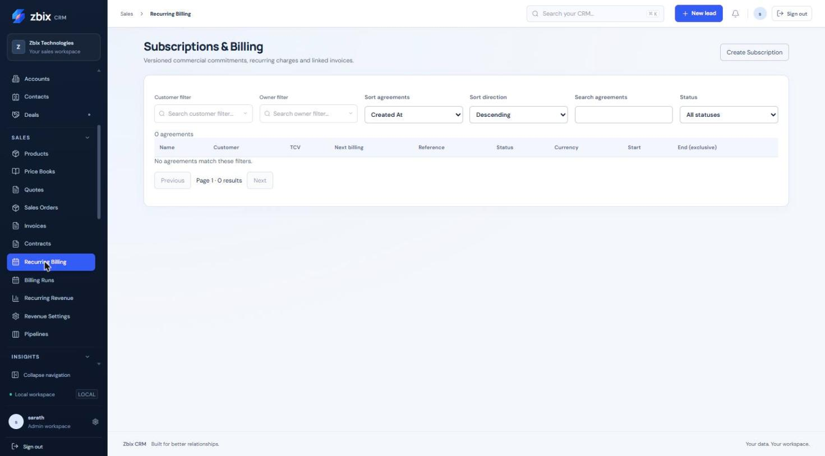
Figure 23 Subscriptions & billing SS-021

Important considerations
- Draft Only is the default. Automatic Issue creates issued CRM invoices; it does not charge a bank account or payment card.
- An omitted lifecycle date uses the next eligible common billing boundary, respecting notice and minimum commitment. Immediate termination can require financial reconciliation.
- Existing invoices are protected. A preview’s existing-invoice links cover the currently loaded history page; inspect the complete paginated Billing history where needed.
- Renewal excludes existing one-time fees. Automatic renewal requires explicit agreement-level authorization.
- Invoice due days and cancellation notice days range from 0 to 365.
- There is no implicit catch-up for ended service periods. Resume does not automatically bill ended suspended history; review skipped runs and obligations explicitly.

Troubleshooting
- No invoices appear: verify Active agreement and schedule status, due date/timezone, worker health and operator permissions.
- Lifecycle change is rejected: inspect the returned boundary, notice, commitment and billed-period constraints.
- An ongoing agreement lacks TCV: this is intentional; review the bounded forecast and recurring run rate.
Related knowledge base articles: Contracts; Billing Runs; Issue Invoices and record payments; Read System Health and verify service readiness.

Billing Runs
Zbix CRM 1.2.0 | Source reviewed | Reviewed 28 October 2026
Billing Runs lists persisted charge periods and worker execution results. Run status, execution status and attempts describe the processing state, while a linked Invoice is the resulting commercial document.
Use this list to trace recurring billing, inspect failures and queue eligible work without creating an unrelated duplicate invoice.

Before you begin
- The user has Billing view permission and current agreement/customer access.
- Queueing or retry requires Billing approve. The configured billing operator must retain the invoice permissions required by the schedule’s mode.

Procedure
1. Open Sales > Billing Runs. Use Run status to filter Pending, Draft Generated, Awaiting Review, Approved, Issued, Voided, Failed, Skipped or Cancelled.
2. Check Agreement / customer, Period, Due, Amount, Status and Attempts. Open the agreement or customer to review the source.
3. Select Execution history to see each attempt’s outcome, message and time. Distinguish No worker attempt yet from a failed attempt.
4. If an invoice exists, select Open Invoice and complete the normal authorized invoice review, issue, PDF or payment-record procedure.
5. For a run without an invoice, correct the documented eligibility or permission issue before using Queue eligible run.
6. From an agreement’s Billing tab, select Preview billing group. Review the customer, currency, service period, invoice date/due date, grouped line details and total.
7. Select Confirm and queue eligible group after reviewing the preview. Refresh Billing Runs after the worker processes it and verify the expected linked Invoice.

Expected result
An eligible queued run is processed through the durable billing workflow and retains its attempt history and invoice linkage.
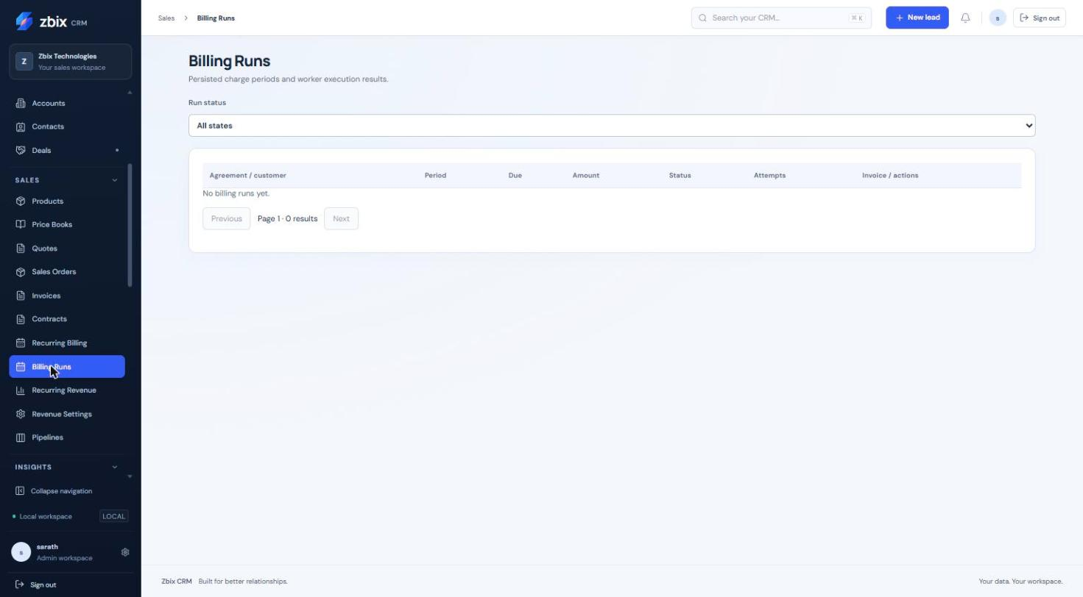
Figure 24 Billing runs SS-022

Important considerations
- Consolidated billing groups only compatible organization, customer, currency, period, date and invoice policy. Listed lines must succeed together.
- Preview confirmation uses a fingerprint, so a changed financial preview cannot be treated as current.
- Queueing is not immediate invoice issuance. The schedule mode and current operator authority determine the result.
- A billing run is not payment settlement. Manual CRM payment records remain separate and require reconciliation.
- A captured No billing runs yet state is a genuine empty result, not a missing screenshot.

Troubleshooting
- Run remains pending: inspect due time, active schedule and worker health.
- Run fails: read its attempt message, correct source/access/configuration issues and queue only eligible work.
- Preview has changed: reopen Preview billing group and review the current figures instead of submitting an old confirmation.
- A run already has an invoice: follow Open Invoice; do not create a replacement by repeatedly queueing.
Related knowledge base articles: Recurring Billing; Contracts; Issue Invoices and record payments; Read System Health and verify service readiness.

Recurring Revenue
Zbix CRM 1.2.0 | Source reviewed | Reviewed 28 October 2026
Recurring Revenue reports opportunity, contracted service and billing measures separately. It preserves currency separation and distinguishes service-period forecasts from expected bookings and actual invoice/payment records.
Use the dashboard for sales and renewal planning. It is a management projection, not an accounting revenue-recognition engine.

Before you begin
- The user has Revenue Analytics view permission and access to relevant source records. CSV export requires the applicable export grants.
- Revenue plans or agreements must be configured before the dashboard can show their forecasts.

Procedure
1. Open Sales > Recurring Revenue. Choose Forecast start and Horizon (3, 6, 12, 24 or 36 months), or enter Custom end (exclusive).
2. Set Currency and Group by Month, Quarter or Year. Refine Owner, Team, Customer, Pipeline, Deal stage and Contract status.
3. Review Billing and renewal work and the separate currency metric blocks. Renewal and pending-run counts use the next 30 days; invoice counts follow the selected range.
4. In Service-period revenue forecast, select Chart sources and Chart measure. Sources include qualified Leads, pipeline, booked and contracted pools; measures include potential, weighted, recurring and one-time.
5. Compare Expected bookings with Scheduled billing. Open a Forecast source link to examine its plan and service dates.
6. Select Export forecast CSV when authorized. Preserve the selected dates, filters and currency when sharing the result.

Expected result
The dashboard recalculates the scoped forecast and operational measures for the selected period, keeping distinct business timelines visible.
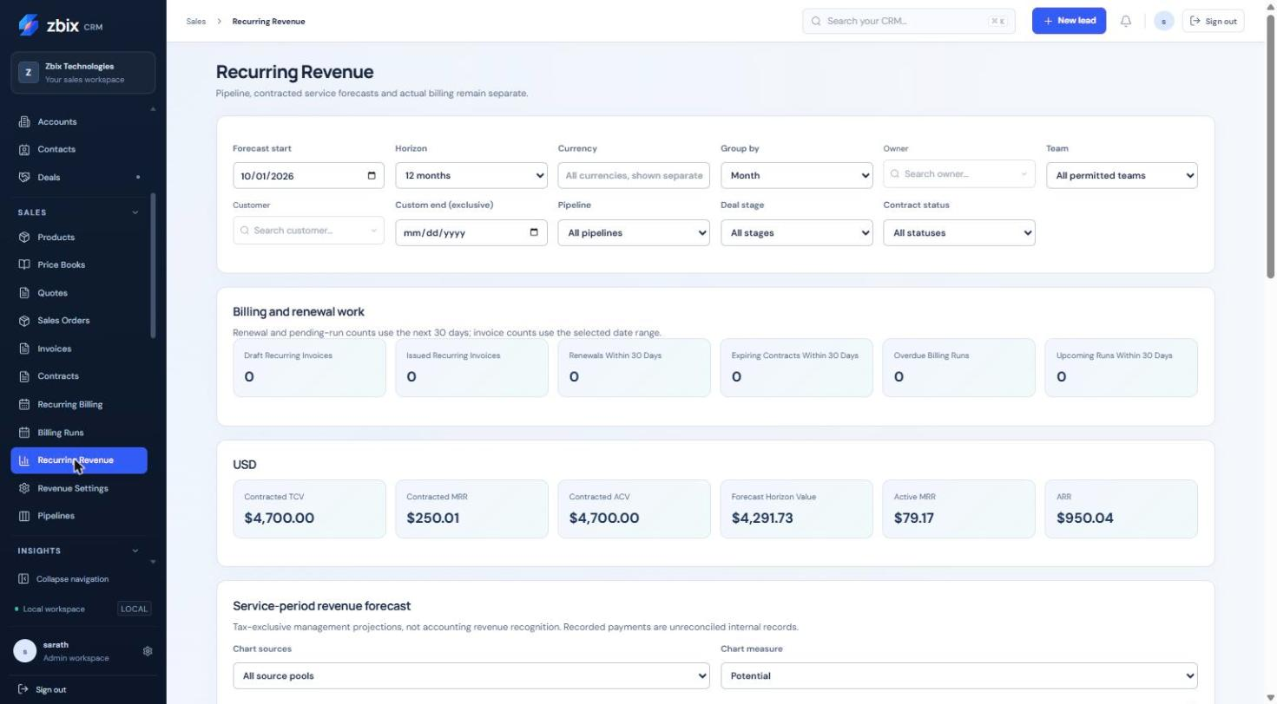
Figure 25 Revenue forecast dashboard SS-023

Important considerations
- Opportunity expected-close dates control bookings; service start/end dates control service projections; scheduled invoice dates control billing.
- Deal Amount follows the revenue plan’s TCV and weighting follows configured stage probability. Qualified Lead potential requires both Qualified Lead status and Qualified estimate confidence.
- Forecast figures are tax-exclusive after discounts; scheduled invoice charges are tax-inclusive. Do not compare them as equivalent amounts.
- An ongoing agreement has no fixed lifetime TCV; a bounded forecast is not a commitment for an unlimited term.
- Recorded payments are unreconciled internal records. Do not present the dashboard as bank-reconciled collections.

Troubleshooting
- No forecast appears: review source plans, period, currency, record permissions and the Lead qualification/confidence conditions.
- Forecast differs from invoice totals: compare tax treatment, service periods, billing dates and source pools before treating the difference as an error.
- A Deal amount cannot be edited independently: change the allowed revenue plan rather than bypassing its managed TCV.
Related knowledge base articles: Contracts; Recurring Billing; Billing Runs; Analyze performance with Reports.

Revenue Settings
Zbix CRM 1.2.0 | Source reviewed | Reviewed 28 October 2026
Revenue Settings supplies defaults used when users configure new revenue plans and billing schedules. Defaults include timezone, due days, horizon, recurring interval, renewal length, notice days, invoice mode, timing and proration.
Use this page to align new agreements with organization policy while retaining explicit agreement-level billing and renewal decisions.

Before you begin
- The user has Revenue Settings view and manage_settings rights.
- Confirm the intended defaults and the recipients who should receive operational notices.

Procedure
1. Open Sales > Revenue Settings and review the current settings before editing.
2. Set Timezone, Due days, Horizon months, Interval months, Renewal months and Notice days.
3. Select Mode (draft, review or issue), Timing (advance or arrears), and Proration (actual days or none). Prefer the deliberate policy approved for new schedules.
4. Under Notification recipients, use Add notification recipient to select eligible users. Use Remove recipient to remove an additional recipient.
5. Select Save defaults and wait for Revenue defaults saved.
6. Create or configure a new plan/schedule and confirm that the defaults are appropriate for it. Review and explicitly authorize automatic renewal on the individual agreement when required.

Expected result
New configuration forms use the saved organization defaults; existing agreement and schedule decisions remain separately controlled.

Fields and controls
Field or control | Rule
Timezone | Valid IANA timezone; default UTC
Due days | 0-365; default 30
Horizon months | 3-36; default 12
Interval months | 1-36; default 1
Renewal months | 1-120; default 12
Notice days | 0-365; default 30
Mode | draft / review / issue; default draft
Timing | advance / arrears; default advance
Proration | actual_days / none; default actual_days

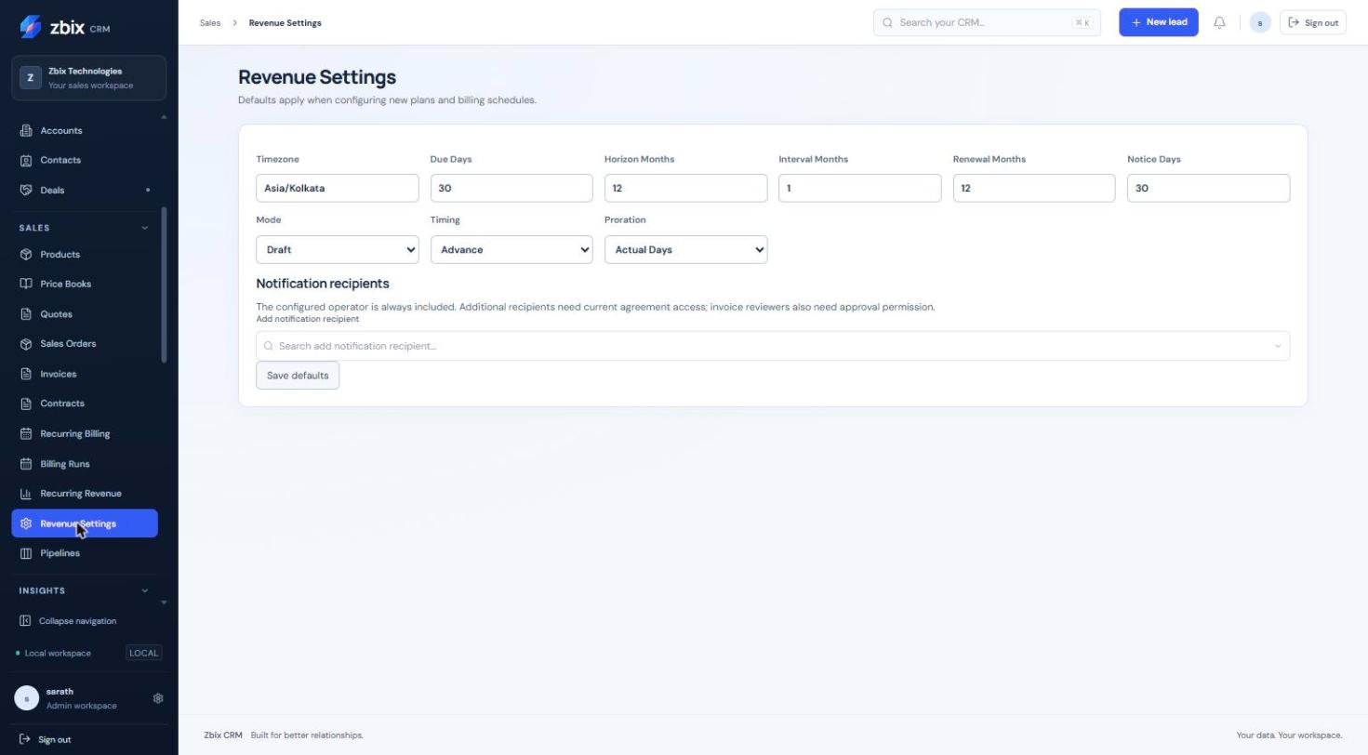
Figure 26 Revenue defaults configuration SS-024

Important considerations
- The configured operator is always included in notifications. Additional recipients must have current agreement access, and invoice reviewers need approval permission.
- Choosing a recipient does not grant access to a record or invoice.
- Automatic renewal is an explicit agreement-level authorization; changing defaults does not substitute for it.
- Currencies must be configured in commercial settings; entering a three-letter code alone does not make an unsupported currency valid.
- Default invoice mode is draft. Selecting issue affects eligible schedule configuration and requires the necessary operator authority at execution.
- Selecting issue as the default requires Invoice approve permission. Up to 20 distinct additional notification recipients are accepted.

Troubleshooting
- Save is unavailable: verify manage_settings on Revenue Settings.
- A recipient is rejected: choose an active user in the same organization and remove duplicates.
- Existing schedules differ from new defaults: review and update the intended schedule through its own authorized Billing controls rather than assuming a retroactive change.
Related knowledge base articles: Recurring Billing; Contracts; Module Permissions; Billing Runs.

